**SECTION 1: fMRI Preprocessing and Data Manipulation**

**OVERVIEW:**

1. Installation Guides
   1. FSL/FreeSurfer
   2. NeuroElf
   3. MRICron
   4. BrainVoyager Licensing
2. Getting Data
3. Segmentation
4. FSL/FreeSurfer Retinotopy Procedure
   1. Preprocessing
   2. Painting
   3. Retinotopy in TKSurfer
5. Using AutoRA_FSL
6. BrainVoyager Stream
   1. Preprocessing
   2. Retinotopy Preprocessing – BrainVoyager
   3. Retinotopy Preprocessing – FreeSurfer Segmentation
   4. Retinotopy

**Installation Guides**

1. **FSL/FreeSurfer**
   1. **Set-Up**
      1. Download the appropriate .dmg file from the FreeSurfer web page (http://surfer.nmr.mgh.harvard.edu/fswiki/Download)
      2. Most of the lab uses the Mac OS X Leaopard version – on the page it is called [freesurfer-Darwin-leopard-i686-stable-pub-v5.1.0.dmg](ftp://surfer.nmr.mgh.harvard.edu/pub/dist/freesurfer/5.1.0/freesurfer-Darwin-leopard-i686-stable-pub-v5.1.0.dmg)
      3. Continue to the next page of the FreeSurfer Wiki, called FreeSurfer Installation and click the Mac OS X Installation
      4. Follow the instructions on that page (mostly describing how to unpackage and install the .dmg file – it’s not hard), then continue to the next page, called FreeSurfer Setup and Configuration.
      5. Now, this page tells you how to set FreeSurfer up in both C shell (csh or tcsh) and bash (sh) – our lab mostly uses bash, so we will follow those instructions. **NOTE: this guide is an easier to follow version of that tutorial, if anything is giving you trouble, use Google for help or consult the original guide closely.**
      6. In the shell terminal, type:

export FREESURFER_HOME=<insert installation directory here>/freesurfer

source $FREESURFER_HOME/SetUpFreeSurfer.sh

* + - 1. This step defines the installation directory you put where the < > are (be sure to not include the < > in the command line) as the variable FREESURFER_HOME and then runs the SetUpFreeSurfer.sh file to setup the appropriate FreeSurfer environment
      2. To avoid doing this every time you want to run FreeSurfer, you can configure this to run automatically, however, this requires you to mess around with the system files, which can be dangerous. If you’re not sure what you’re doing, definitely ask someone for help.
      3. Ultimately, we need to edit what are known as “hidden files” – system files that the operating system usually makes invisible to prevent users from messing with them. To access these we need to make them un-hidden:
         1. In your shell terminal type:

defaults write com.apple.Finder AppleShowAllFiles TRUE

killall Finder

* + - * 1. This sets Finder to show hidden files and then kills all the Finder windows
        2. Open a new finder window and go under your Home folder (typically tonglab) and look for a file named .bash_profile or .bashrc
        3. If that file doesn’t exist, open your text editor and save a file in the home directory named .bash_profile
        4. In this file, type the following (this is what I have in my file):

FSLDIR=/usr/local/fsl

. ${FSLDIR}/etc/fslconf/fsl.sh

PATH=${FSLDIR}/bin:${PATH}

PATH=/Applications/fsl/bin:${PATH}

export FSLDIR PATH

export FREESURFER_HOME=/Applications/freesurfer

source $FREESURFER_HOME/SetUpFreeSurfer.sh

* + - * 1. Save this file out – this file sets your shell terminal to setup the freesurfer environment automatically whenever you open it
        2. You will definitely want to hide the hidden files when you’re done, so run the following to make them hidden again:

defaults write com.apple.Finder AppleShowAllFiles FALSE

killall Finder

* + - 1. Ok, now you have set the environment for freesurfer/FSL. To see if this worked quit out of your shell terminal and open it up again, it should output the following:

-------- freesurfer-Darwin-leopard-i686-stable-pub-v5.0.0 --------

Setting up environment for FreeSurfer/FS-FAST (and FSL)

FREESURFER_HOME /Applications/freesurfer

FSFAST_HOME /Applications/freesurfer/fsfast

FSF_OUTPUT_FORMAT nii

SUBJECTS_DIR /Applications/freesurfer/subjects

MNI_DIR /Applications/freesurfer/mni

FSL_DIR /usr/local/fsl

* + - 1. If this didn’t work, go very carefully through the tutorials outlined on the freesurfer/FSL wikis, I could have typed something incorrect here, but I don’t think so :}
  1. **File Structure**
     + 1. Okay, so now you’ve set up your terminal to automatically run in the FSL/FreeSurfer environment, the next step is to organize your directories in a way that makes sense to you.
       2. *There will be* ***two*** *main directories to work in*: the directory in which your segmentation files will be put by FreeSurfer and the directory in which your original PAR/REC files along with the rest of your retinotopy files will be held
          1. **Subject Data Directory**

Designate a directory where you want to keep all of your retinotopy data and run your retinotopy analysis from (in this example I will be using: /Volumes/Data/fMRI_Data/Retinotopy/FSL_Retinotopy/M076 (M076 is the subject name, you want to make it correspond to whoever your subject is)

* + - * 1. **FreeSurfer Data Directory**

By default, FreeSurfer makes a subject directory of its own in its home folder (usually: /Applications/freesurfer/subjects)

Typically, we may want the subjects folder to be in a more accessible location

In this example, I’ll be setting up a folder on one of Tesla’s Data hard drives (Tesla is the RA Mac Pro) as FreeSurfer’s subject directory

If you remember from setting up FreeSurfer, a file called SetUpFreeSurfer.sh is called to define various aspects of the program’s file structure

Open this file (by default you can find it under /Applications/freesurfer – be sure to open the .sh file and not the .csh file as we set this up for bash (sh))

You will see a few lines of code that set the SUBJECT_DIR variable to a given location on the hard drive, by default it should be:

if [ -z $SUBJECTS_DIR ]; then

export SUBJECTS_DIR=$FREESURFER_HOME/subjects

fi

First, save a copy of SetUpFreeSurfer.sh somewhere else (name it SetUpFreeSurfer _backup.sh or something) in case you mess something up.

We want to change $FREESURFER_HOME/subjects to the directory we want to use for our segmentation output. In this example I want to set the directory to /Volumes/Data/fMRI_Data/Freesurfer_subjects

In SetUpFreeSurfer.sh, type that path after SUBJECTS_DIR= so that your code looks like this:

if [ -z $SUBJECTS_DIR ]; then

export SUBJECTS_DIR= /Volumes/Data/fMRI_data/Freesurfer_subjects/

fi

Now save that file and restart your terminal, upon starting it again, it should now output:

-------- freesurfer-Darwin-leopard-i686-stable-pub-v5.0.0 --------

Setting up environment for FreeSurfer/FS-FAST (and FSL)

FREESURFER_HOME /Applications/freesurfer

FSFAST_HOME /Applications/freesurfer/fsfast

FSF_OUTPUT_FORMAT nii

SUBJECTS_DIR /Volumes/Data/fMRI_data/Freesurfer_subjects/

MNI_DIR /Applications/freesurfer/mni

FSL_DIR /usr/local/fsl

Congrats! Hopefully FSL/FreeSurfer are now ready to use! If something went wrong, consult the wikis on the FreeSurfer page or use Google, or ask another lab member for help.

1. **NeuroElf**
   1. NeuroElf is a program I use to convert between fMRI image file types that are used in the BrainVoyager (.vmr) and in FSL/FreeSurfer (.nii).
   2. To install it, follow the instructions on the following webpage: [http://neuroelf.net/wiki/doku.php?id=neuroelf_installation&s[]=installation](http://neuroelf.net/wiki/doku.php?id=neuroelf_installation&s%5b%5d=installation)
   3. Those instructions were generally good, but I ran into trouble compiling MEX files (these are C-based files that MATLAB can use to increase processing speed). There is a useful link on the page provided above (<http://neuroelf.net/wiki/doku.php?id=neuroelf_mex_files>) which may help you to compile your files if your installation isn’t working.
   4. Assuming you are using Mac OSX, you will need to install a compiler (I did this using XTools, which contains the GCC compiler). Once a compiler is installed, the installation should run smoothly.
   5. Again, Google and the NeuroElf wiki will be invaluable in this process!
2. **MRIron**
   1. MRIron is a program used for converting between different file types. We pretty much only use its dcm2nii function to convert our PAR/REC files into NiFty filles (.nii) useable by FreeSurfer and FSL.
   2. An easy to install program; just go here and follow the installation instructions for your operating system: http://www.mccauslandcenter.sc.edu/mricro/mricron/install.html
3. **BrainVoyager and the HASP Server** (Ben Wolfe, April 2010)
   1. BrainVoyager requires a HASP license code from the server whenever you want to use it, we have an eeePC dedicated to running this server in the breakroom. If you are getting a licensing error, there are some things to check:
      1. *Does the computer have the correct nethasp.ini file?*

The BrainVoyager folder should have a nethasp.ini file in it listing the following IP as a permitted server: 129.59.230.107

* + 1. *Is the computer connected to a network?*

Given that HASP is a network authentication standard, the computer must be plugged in to the network. Check for an unplugged cable, or disconnected wifi.

* + 1. *Has the server died?*

The eeePC server isn’t used for anything else, so it should remain stable. But if it is turned off, turn it back on; if it has crashed, reboot it.

* + 1. *What if the eeePC is broken/died horribly?*

Find a working computer, install the HASP server software (Allume Systems, use Google), plug in the dongle and reboot the system.

* + 1. *I am running Windows in a virtual environment and I keep getting licensing errors?*

This seems to happen a lot, usually if you restart the routine you are doing/reboot the virtual machine/reboot the host computer it should go away.

**Getting Data**

* 1. If you’ve never nabbed PAR/RECs before, here’s how you do it:
  2. First you need to ssh into the 3Tb server using your VUIIS id (fmriuser) and password (see the super secret RA password list). You can do this by typing in the following: ssh fmriuser@vcn0.vuiis.vanderbilt.edu and then typing in your password when it prompts you (see the RA password list if you don’t know it).
  3. After you’ve entered the correct password and are logged in, you need to move the PAR/REC files from the temporary 3Tb server to their long-term one; the people at VUIIS have written us a handy script to allow us to do that: /home/CHI/3Tb_mv_ParRec Tong
  4. Now, typing Tong at the end tells the script to take any files starting with Tong and to move them to the permanent server, so if you have multiple studies on the temporary server, it will move all of them off. You will know when this is done when it gives you an error, something to the tune of ‘there are no files labeled Tong,’ or something.
  5. So, to move these files from that permanent server to your computer, you’ll need to use FileZilla (on Tesla, it’s the program with the logo that looks like a red postage stamp with a white ‘FZ’ on it)
  6. Open FileZilla, and in the upper left corner is a picture of a little computer connecting to a server (if you mouse over it it should say ‘Open the Site Manager.’
  7. Click this icon and you should see a bunch of server accounts already set up (unless it’s a new install of FZ, then you will need to configure them yourself). Click the VUIIS site and click Connect.
  8. This should load the VUIIS server file tree on the right side of the FZ screen (under Remote site)
  9. For ease of use, I usually sort the files by Last Modified, so if I recently ssh’ed the data I can find it simply by scrolling down to the last modified folder.
  10. These folders are named ParRec_[day][Month][year][time] of retrieval, which is kind of a pain, but just poke around until you find your files with the right study number, they’re usually there.
  11. Once you find your files, you simply drag them to the left side of the screen (under Local site) into the directory you want them in. You should always save them into a folder with the full subject ID on it (e.g. 120729M076) and upload that folder to the teba archive asap (this can also be done through FileZilla).
  12. **Note:** there is a new script called ‘getstudy’ which allows for more options for file conversions for your data. However, this script takes longer and we generally do not use it, but in case you need to use it, here is how:

Usage: /home/CHI/getstudy [options] Tong_<insert study number here>

Options:

-v: verbose output

-k: keep DICOM images

-o: create old version of PAR/REC (v4.1)

-s: use simple file name prefixes

-u username: provide vuNetID through command line

-p password: provide vuNetPassword through command line

-d: specifiy output directory

**Segmentation in FreeSurfer**

* 1. So, before you can do a retinotopy in FreeSurfer or BrainVoyager, you need to first segment your brain data. Segmentation is the complicated and time-consuming process of delineating grey from white matter in the brain, and delineating brain matter from non-brain matter. FreeSurfer and BrainVoyager both have automated segmentation functions, but the quality of a BrainVoyager segmentation is AWFUL and used to require hours an hours of hand made corrections. To get around this, all segmentation is now done in FreeSurfer, and here’s how:
     1. If you are just segmenting for an FSL retinotopy, your segmentation is pretty easy. First you want to convert your high resolution anatomical file from a PAR/REC into a .nii file.
     2. First, cd into the location of your high res anatomical (this is usually the third run of any retinotopy). Once you’re there enter the following into the terminal (replacing <file> with the directory and filename of your anatomical file):

dcm2nii –a n <file>

* + 1. Check to see if the new file made is a .nii or .nii.gz file. If it is .nii, you are fine, if it is .nii.gz you will need to double click it to convert it to .nii. Now that your file is in the right format, you are ready to segment. Make sure you are still in the directory of your .nii anatomical file and type the following:

recon-all -subjid <subject id> -i <file> -all

(another example, just so you understand the input)

recon-all -subjid M078 -i Tong_307289_03_1.nii -all

* + 1. If there have been no errors, that means your segmentation should be underway. Note that this process takes a LONG time, roughly 24 hours, depending on your computer. **It is the kind of thing you will want to start at the end of the day before you leave, so it can run over night.**

**FSL/FreeSurfer Retinotopy Procedure**

**For this processing stream, there are a few bash/sh scripts that you will be using and should be familiar with what they do. These instructions more or less run through the scripts step by step. These scripts are meant to work by copying and pasting each step and running it in the terminal.**

**Scripts: (if you don’t already know where they are located, ask a lab member)**

RetinoScript_CA_Edit.txt

paint_retino.csh

run-lh-tksurfer (for the left hemisphere)

run-rh-tksurfer (for the right hemisphere)

**Data:**

Original PAR/REC files

Segmentation output from freesurfer

**PROCEDURE OVERVIEW**

**Preprocessing:** This is where you are preparing your data for analysis by doing motion correction, registration, polar frequency averaging, reorienting your data, etc.

**Painting:** This takes your functional data and maps it onto an anatomical reconstructed surface.

**Retinotopy in TKSurfer:** This is where you look at your surface maps and determine where different anatomical areas are in the visual cortex.

1. **Preprocessing**
   1. The main script is called RetinoScript_CA_Edit.txt and the comments in there briefly explain how/why to run each step.
   2. This first section defines a bunch of different variables: SUB = subject ID, SUBJECTS_DIR = the directory where you want your segmentation files to be, RETINO_DIR = the directory where you want your retinotopy files to be, NUM_POLAR/ECCEN/FFA = the number of each type of run, this comes in handy later for some for loops. Example:

SUB=F078

SUBJECTS_DIR=/Volumes/Data/fMRI_Data/Freesurfer_Subjects

RETINO_DIR=/Volumes/Data/fMRI_Data/Retinotopy/FSL_Retinotopy

NUM_POLAR=10

NUM_ECCEN=3

NUM_FFA=3

* 1. Now run the next two pieces of code, which check to see if a retinotopy folder is made/makes one and makes a bunch of subdirectories.

# Check to see if retinotopy folder has been made, if not, make it

if [ ! -e $RETINO_DIR/$SUB ]

then

mkdir $RETINO_DIR/$SUB

fi

# Make data analysis directories

mkdir $RETINO_DIR/$SUB/Eccen

mkdir $RETINO_DIR/$SUB/FFA

mkdir $RETINO_DIR/$SUB/MriData

mkdir $RETINO_DIR/$SUB/omnibus

mkdir $RETINO_DIR/$SUB/parrec

mkdir $RETINO_DIR/$SUB/Polar

mkdir $RETINO_DIR/$SUB/Retino

* 1. Now you want to get all of your PAR/REC files for this retinotopy subject and move them into the parrec subdirectory you just made. Then convert those files to compressed .nii.gz files and move them into the MriData directory by running the next few lines of code:

# Make Par/Rec into .nii.gz, then move them to MriData directory

# (need to get dcm2nii and alias it in .bash_profile)

cd $RETINO_DIR

dcm2nii -a n $RETINO_DIR/$SUB/parrec

find . -maxdepth 1 -type f -name '*.nii.gz' -exec mv {} $RETINO_DIR/$SUB/MriData \;

* 1. Now you want to rename all of your nii.gz files by hand according to what run they were. You will probably want to do this based on your scan record to make sure you make no mistakes. You will start with a messy .nii.gz file name, and change each one to a nice, short, run name (e.g. f20120928_140537Tong_207916_04_1WIPTestEPICLEARTong_207916s004a001.nii.gz 🡪 polar1.nii.gz). Be sure to cross reference which run it is to the scan number; polar1 is usually scan number 7 or 8, eccen1 is usually scan 9 or 10. Be very careful renaming these files as mistakes can really mess up the retinotopy.
  2. Next put all of your files in the proper orientation by running:

# Put in proper orientation (be sure to be in RETINO_DIR/SUB/MriData)

for fn in *.nii.gz

do

fslswapdim "$fn" RL PA IS "$fn" &

done

* 1. Now you want to do motion correction, first making a registration run:

cd $RETINO_DIR/$SUB/MriData

# Motion correct the file you want to register to

mcflirt -in FFA1.nii.gz -out tmpRegRun.nii.gz

# Calculate the mean over time for this registration run

fslmaths tmpRegRun.nii.gz -Tmean FFA1Mean.nii.gz

rm tmpRegRun.nii.gz

* 1. Then by doing motion correction for the FFA runs, Polar runs, and Eccen runs in turn. You will want to do each of these one at a time, because otherwise you can overload your RAM and it will lock up your entire system (here is the FFA motion correction loop for an example: )

# FFA Motion Correction

for ((i=1; i<=NUM_FFA; i++))

do

mcflirt -plots -in `printf "FFA%01d.nii.gz" $i` -reffile `printf "FFA1Mean.nii.gz"`&

done

wait

* 1. Next, concatenate all of the par files into a single motion corrected file:

# Concatenate all par files into

cat *.par > allMCF.par

* 1. You should now view the motion correction in MATLAB, there are various way to do this, I believe you could steal some functions from autoRA. I wrote a very quick and dirty script that will give you the general plots in Matlab.
  2. Assuming the motion wasn’t to bad, continue to register the segmented brain to the registration run you made before, then check the results in FSL and make adjustments if you need.

# Registers the segmented brain to the template file and spits out a transformation matrix (.dat)

cd $RETINO_DIR/$SUB/MriData # Be sure to cd into the segmentation directory

bbregister --bold --s $SUB --mov FFA1Mean.nii.gz --init-fsl --reg regFunc2Surf.dat &

# To check results and make adjustments if need be:

tkregister2 --mov $RETINO_DIR/$SUB/MriData/FFA1Mean.nii.gz --reg $RETINO_DIR/$SUB/MriData/regFunc2Surf.dat --surf &

* 1. Next you want to run polar frequency averaging, the main processing routine that allows us to take functional data, analyze its spatial frequency, and ultimately place it onto an anatomical volume. The first part of the code creates the proper inputs and the second part uses those inputs for the frequency averaging. Again, do these step-wise, as they take some processing power and time (so do all polar runs first, then eccen).

########### Polar Frequency Averaging #########################################

# Create properly formatted input strings to put into selfreqavg function

tag="-i"

input=""

direction=""

for ((i=1; i<=$NUM_POLAR; i++))

do

input+=`printf ' %s %s/%s/MriData/polar%01d_mcf.nii.gz' $tag $RETINO_DIR $SUB $i`

direction+=`printf ' -direction pos'`

done

# Frequency Averaging

selfreqavg $input -TR 2 -o $RETINO_DIR/$SUB/Polar/h -stimtype polar -ncycles 8 $direction &

1. **Painting Functional Activity**
   1. As noted by the RetinoScript, this next section asks you to run a script called paint_retino.csh.
   2. This script requires uncompressed .nii files… you can uncompress your files by double clicking each in turn
   3. Before you run it, you need to edit it to reflect which files you are analyzing and your subject name. The fields highlighted below are the ones you will need to change, making them the appropriate directory in which your registration file is and desired output will be and the appropriate run stimulus type (Eccen or Polar):

#!/usr/bin/env csh

set outdir = /Volumes/Data/fMRI_Data/Retinotopy/FSL_Retinotopy/F078

set regdir = /Volumes/Data/fMRI_Data/Retinotopy/FSL_Retinotopy/F078/MriData

set type = Polar

set outstem = h

set surf = smoothwm

set projfracarg = ( --projfrac-avg 0 1 0.5 )

#set projfracarg = ( --projfrac 0.75 )

foreach hemi ( rh lh )

mri_vol2surf --srcvol $outdir/$type/$outstem.nii --src_type nii --srcreg $regdir/register_init.dat --surf $surf --hemi $hemi $projfracarg --interp trilinear --frame 0 --out_type paint --float2int round --mapmethod nnf --o $outdir/$type/sigf-$hemi.w

mri_vol2surf --srcvol $outdir/$type/$outstem.nii --src_type nii --srcreg $regdir/regFunc2Surf.dat --surf $surf --hemi $hemi $projfracarg --interp trilinear --frame 1 --out_type paint --float2int round --mapmethod nnf --o $outdir/$type/sig2-$hemi.w

mri_vol2surf --srcvol $outdir/$type/$outstem.nii --src_type nii --srcreg $regdir/regFunc2Surf.dat --surf $surf --hemi $hemi $projfracarg --interp trilinear --frame 2 --out_type paint --float2int round --mapmethod nnf --o $outdir/$type/sig3-$hemi.w

end

* 1. Once all your variables are set, go to the terminal and make sure to cd to the directory where the paint_retino script is located, then type ./paint_retino.csh
  2. Now repeat steps c through d, except setting type to Eccen (note that capitalization is key here, make sure your variable matches your file structure name).
  3. You just ‘painted’ the preprocessed functional data from the different retinotopy runs onto an anatomical volume, the next step is to use tksurfer to delineate the different retinotopic regions.

1. **Retinotopy in TKSurfer**

**\*\*\* The following steps must be done for each hemisphere \*\*\***

* 1. From here you will need to work in TKSurfer, a GUI designed to interact with surface plots. This section is best grasped by experience, but I will attempt to explain the process. Ideally, you will learn how to do this by watching someone else do it, then completing it yourself.
  2. Before running TKSurfer, there are two csh scripts you will need to edit, called run-rh-tksurfer and run-lh-tksurfer. For each script, you need to edit what the name value is to your subject ID, then set the script to either paint on the Polar maps or the Eccen maps.
  3. To specify Polar or Eccen, look for the sections of the scripts titled ECCEN SETTINGS or POLAR SETTINGS. If you are running polar, you want to comment out (put a # in front of) all of the ECCEN SETTINGS, and vice versa for when you want to run your eccen data (see below excerpt for an example to run polar).

###### ECCEN SETTINGS ######

#setenv fthresh 1.0

#setenv fslope 10

#setenv fmid 1.05

#setenv angle_offset 0.22

#setenv angle_cycles 1.0

#setenv invphaseflag 0

#setenv smoothsteps 0 #from default

#setenv revphaseflag 1

#setenv FREESURFER_HOME /Applications/freesurfer/

#setenv SUBJECTS_DIR /Volumes/Data/fMRI_Experiments/FreesurferAnatomicals

################-views is for viewing on inflated, -flat for occip patch

##########use inflated to make cuts using retino data

#setenv rgbname eccen

#tksurfer -$name $hemi inflated -tcl $FREESURFER_HOME/lib/tcl/eccen-flat.tcl

#tksurfer -$name $hemi inflated -tcl $FREESURFER_HOME/lib/tcl/eccen-views.tcl

###### POLAR SETTINGS ######

#setenv fthresh 0.4

#setenv fslope 2

#setenv fmid 0.8

setenv fthresh 1.3

setenv fslope 10

setenv fmid 1.4

setenv angle_offset 0.45

setenv angle_cycles 2.0

#setenv angle_cycles 1.0 # s6 scanned with double-wedge stim

setenv invphaseflag 0

setenv revphaseflag 0

setenv smoothsteps 0 #was 5

setenv rgbname polar

#tksurfer -$name $hemi inflated -tcl $FREESURFER_HOME/lib/tcl/polar-flat.tcl -invphaseflag $invphaseflag

tksurfer -$name $hemi inflated -tcl $FREESURFER_HOME/lib/tcl/polar-views.tcl

* 1. The two highlighted lines are the most important to make sure are uncommented, as they will be drawing your textures. After making the edits and specifying that we want to run our polar data, save this file in the directory above your subject’s retinotopy directory (if it was saved in /Users/Volumes/fMRIData/M075 then you would want to save it in /Users/Volumes/fMRIData).
  2. Change to the directory where you just saved your run-rh-tksurfer file and run it by typing ./run-rh-tksurfer
  3. Assuming you’ve done everything right so far, you should now be seeing a reconstructed surface with polar run activity mapped out onto it. If this hasn’t worked, check to make sure you’re in the right directory, have assigned the right variables, etc.

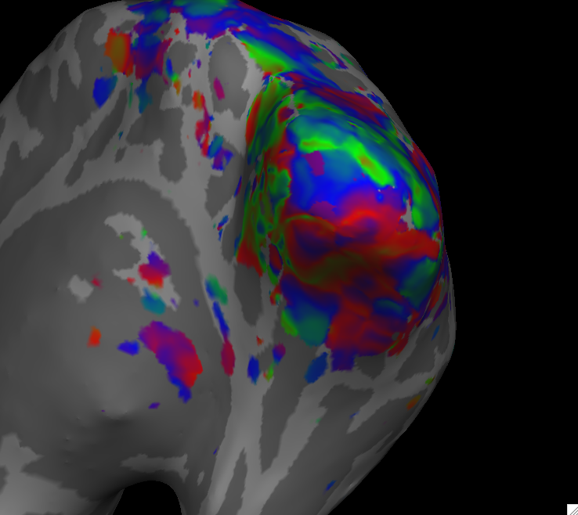

* 1. What you want to be seeing are striations that converge at the occipital pole, as I have marked in the image above. If you can’t see them well, go to View>Configure>Phase Encoded Data Display and alter the angle offset by .05 until you can see the striations as clearly as possible on both dorsal and ventral surfaces.

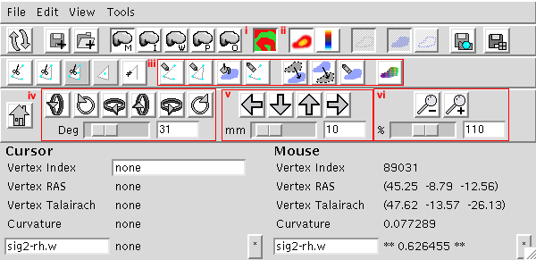

* 1. Just some quick notes about the toolbar before we get down to the nitty gritty:
     1. *Toggle overlay*: this will toggle the color map overlay, good for looking at the anatomical details to make line judgments later
     2. *Toggle curvature*: when the overlay is disabled, this button will toggle a gyri/sulci overlay, also useful to see where different brain landmarks are
     3. *Path/fill/label tools*: these will be used to draw labels for each anatomical area
     4. *Rotation tools*: use these buttons to rotate your brain, the slider determines how many degrees each click will rotate
     5. *Translation tools*: same as rotation, but translation
     6. *Zoom tools*: pretty self explanatory
     7. *When in doubt of a tools function, mouse over it*.
  2. Ok, at this point, you’re ready to begin drawing the labels for the different visual cortex regions. This part is very open-ended, as you are drawing by hand, and it takes a couple of times to get used to identifying regions. It always helps me to use previous retinotopies as a reference. Again, the only way to get better at this is by doing.

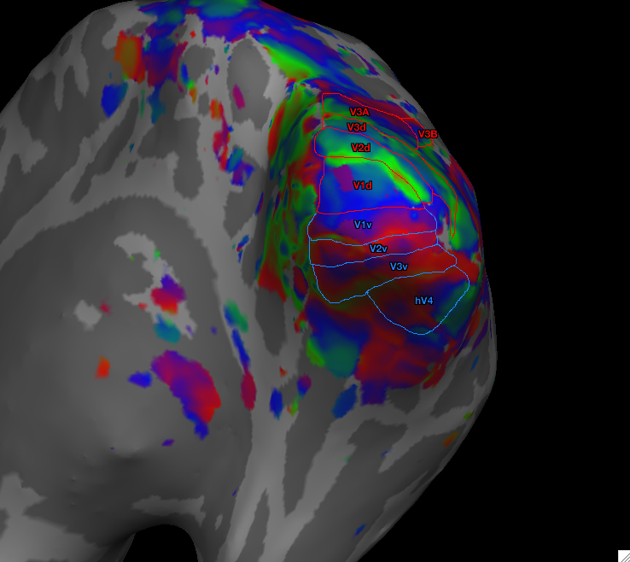

* 1. I made the image above to give you a rough idea of where the different brain regions are. Again, have a lab member show you how to do this as you will understand much better as you watch them work.
  2. The key idea is to use the colors to tell where boundaries are, as the phase encoding of each retinotopic area depends on what color value was assigned to that particular phase. If you look at the image above, the calcarine sulcus is most likely under the large blue boundary between V1d and V1v (you can check this by toggling the overlay). It is usually here where I start.
  3. To draw, click the *make path* button (first button from (iii.) referenced earlier… you can mouse over each button to tell what it does). To outline V1d, click along the calcarine and then continue outlining to the middle of the green striation **(as a general rule, V1 through V3 each cover only half a color cycle – i.e. blue to green or blue to orange - ,while hV4 and V3A/B will cover a full cycle – i.e. green all the way through blue to orange).**

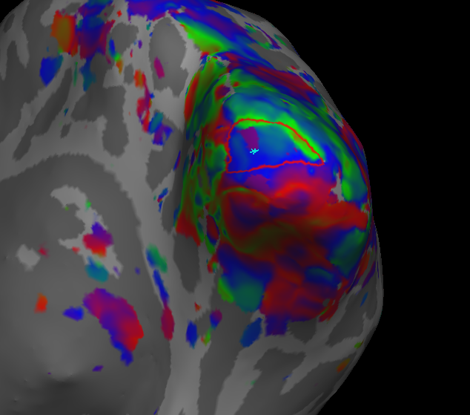

* 1. Once you’ve outlined V1d, click *make closed path* (directly to the right of the make path button) and you should see a red outline form from the points you defined.
  2. Now you want to fill your path to make a label, so click the *custom fill* button (to the right of the closed path button). This should invoke a dialogue box with a bunch of options, you want to make sure that “Up to and including paths” and “Up to other labels” are checked off. Everything else should be fine as is.
  3. 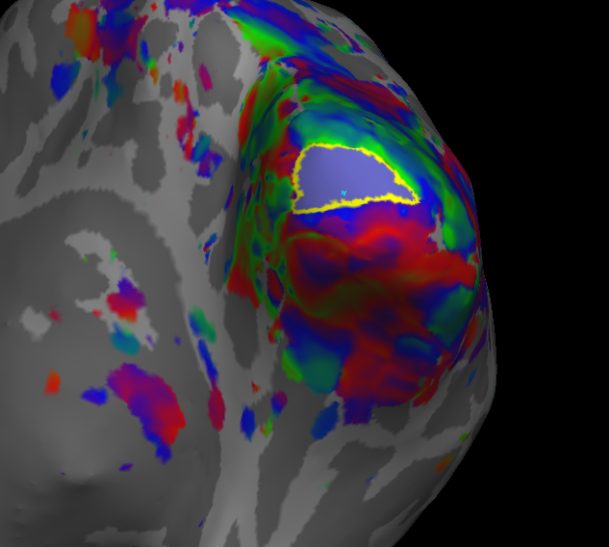To fill make sure your path is selected by clicking within it (it will turn yellow), then click “Fill” in the dialogue box. It should now be filled with an ugly purple color.
  4. Now to define your label, make sure your filled path is selected and go to File>Label>Save Selected Label. Click Browse and navigate to the directory that your segmentation is stored in, saving your label in your subject’s folder in the “label” directory. For each label, you want to save it with the area name, followed by the hemisphere you’re working on (for this example, it would be named V1d-rh.label).
  5. No go on to the next dorsal area, V2d. Because of our fill settings, our paths can overlap (see image below) and it will be alright: the fill will only color through the boundary of the previous label. This means you can draw through the previous label and continue drawing to the middle of the next half color cycle (blue).
  6. 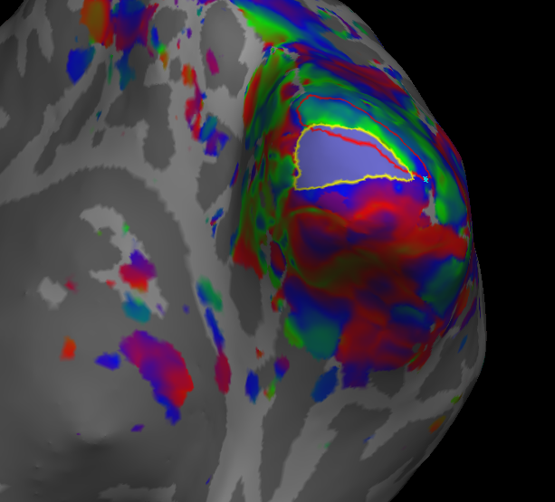Continue this process: drawing a path, closing it, filling it and creating a label up through the rest of the dorsal areas, then go and do all of the ventral areas. Repeat this process for the other hemisphere as well. Be sure to save your labels with the appropriate name and hemisphere (full list of labels for a typical retinotopy: V1, V2, V3 (dorsal and ventral), V3A and V3B (dorsal), hV4 (ventral)).
  7. Once you made and saved all of your labels you are done! Be sure to upload the reconstruction to Teba under Teba>FreeSurferRecons. Within your new subject folder on Teba, under the label folder, make a new folder named retino_labels, and move all of the labels you just made into that folder.
  8. In Teba>FreeSurferRecons read and edit the two log files (FS_retino_labels.txt and FS_recon_log.txt).

SOME OTHER NOTES

* if you mess up while drawing a path, the delete path tool or going to Edit>Unmark All Vertices can be helpful
* play with the other tools… some can erase entire labels, some can toggle label transparency, recolor your labels, etc. – they can be useful as well

**Using AutoRA_FSL**

AutoRA_FSL.m is a MASSIVE Matlab script that was originally written by Devin Brady in 2008 and has been heavily modified since then by Benjamin Wolfe. Its primary function is to automatically preprocess fMRI data. While the script is very useful, it is also quite particular, requiring specific file types, file names, data structures, Matlab versions, Operating Systems, etc. at various stages in preprocessing. *For example, when prompted to press 1 to continue, you MUST use the 1 above the keyboard, not the number pad, as the 1 on the number pad will crash the program.*

AutoRA_FSL is essential in the BrainVoyager processing stream. The previous sections detailed how to run retinotopy in FSL/FreeSurfer, but the following section will cover retinotopy in BrainVoyager, so knowing how to use AutoRA is essential.

What you need to run autoRA_FSL:

* Matlab R2007b (it is important to have this version, there are bugs in other versions)
* BVQXTools (BrainVoyager Tools for Matlab)
* VUTools (VUIIS Matlab Tools)
* FSL
* Virtual Box with a copy of Windows XP
* Mac OSX
* BrainVoyager
* PAR/REC files
* A retino_to_go folder for your subject (see BrainVoyager Retinotopy Section)

1. **In Mac OSX** (this will NOT work in Windows)
   1. Open Matlab R2007b and run autoRA_FSL.m. It will first ask for a directory that you want to preprocess. Find it and select it and autoRA will begin making the proper folder structure.
      1. IMPORTANT: if your file names are not in the format Tong_XXXXXX_XX_1 the automated renaming script will create an error. I’ve made an automated script that will rename the files to the proper format, called renameParRec.m.
   2. *Scan Record*
      1. This will be a text file that allows you to edit the eventual scan names – you will want to name them something more identifiable than “---“
      2. IMPORTANT: you need to set the output name of the test EPI (usually scan 4) to “test_EPI” or you will get an error
      3. IMPORTANT: you need to delete the “WIP_” in front of the B0 map (“Ax_B0map”) or you will get an error
      4. IMPORTANT: if a scan was stopped early while you were at the scanner, you need to remove it from the data set before running autoRA, otherwise it will cause an error. An easy way to tell if you have a short scan is to look at the PAR_SIZE to see if it is different from the others.
      5. Once you’ve done this, save and continue.
   3. *Field Mapping*
      1. This was included in previous versions of autoRA, but the lab currently doesn’t use it. Refer to the previous version of the lab manual if this is needed.
   4. *Distortion Correction*
      1. This is another function that we often do not use. Refer to the previous manual if you need it.
   5. *Motion Correction*
      1. The current version uses MCFLIRT to motion correct the data, first converting PAR/RECs to 3D-ANALYZE format, then collapsing them in time to 4D-ANALYZE format.
      2. Motion correction of the 4D files takes a little while, so find something fun to do in the meantime.
      3. Once correction is finished, 4 plots will be presented (2 for translation and 2 for rotation). If you need help reading them, ask a lab member. We usually try to keep motion under 1mm, with our max being 2-3mm.
      4. At this point, you will want to go to the BrainVoyager Retinotopy section to make your alignment files and the necessary .vmr files to continue to automated .vtc creation.
2. **In VirtualBox Windows XP** (will NOT work on Mac OSX)
   1. Start VirtualBox and run autoRA_FSL in Matlab.
      1. IMPORTANT: you will need to have a retino_to_go folder at this stage that has the TAL file, TAL vmr, and ACPC vmr.
   2. Start the script at stage 7, “Across Scan Movies.”
      1. Check the movie in BrainVoyager; there should be very little motion.
   3. You will be prompted to select the TAL vmr; choose the one that shows the whole brain, not a segmented brain or the .tal file.
   4. Confirm the selected files.
   5. AutoRA will generate a sample VTC, you will want to go into BrainVoyager and check its alignment to the anatomical. If it looks bad, you will need to redo the alignment and then start this section again at step 2b. Otherwise, let it continue.
      1. IMPORTANT: keep an eye on the VTC creation. The VirtualBox tends to have connection problems and BrainVoyager will often give you a licensing error. If this happens, don’t fret! Simply close BrainVoyager, then start autoRA again from step 2b… it will continue where it left off.
      2. IMPORTANT: while making VTCs, you cannot run multiple instances of Matlab or BrainVoyager in the VirtualBox.
   6. If all went well you should have a lot of VTCs now, good job :}. If you are preprocessing experimental data, this should be all you need to do unless the researcher needs additional analysis. If you are here from the **BrainVoyager retinotopy**, continue on to the section you left off on… should be IV-B.

**BrainVoyager Stream**

So, BrainVoyager is a relatively easy to use, albeit very frustrating program. It is nice because it is extensively GUI-based, making it easy to use, creating pretty brain pictures. However, its processing power is limited, and it requires LOTS of clicking, which can be a pain at times. Not many people in the lab use BrainVoyager anymore (I believe only Frank and Eli), but, as an RA, I suppose it is your duty to know it for now.

However, out of the need to shorten the preprocessing time, I’ve gone and combined the FSL segmentation process with the BrainVoyager retinotopy stream (crossing streams, one might say XD). This requires a few other programs including NeuroElf and MRIcron. The way I have written this BrainVoyager stream is intended to be able to discuss BrainVoyager retinotopy and regular preprocessing (for experimental data).

**Programs Used**:

* BrainVoyager
* FreeSurfer
* NeuroElf
* Matlab (autoRA_FSL.m)
* MRIcron

**Data Needed:**

* PAR/RECs
* Motion-corrected autoRA_FSL data

**Some thoughts before you begin:**

* These instructions are based on previous BrainVoyager notes edited many times by previous RAs. Some of these previous instructions are quite detailed, but are inaccurate, whereas others are quite accurate, but not very detailed. I will include previous instructions at the back of this lab manual, but be cautious when using them, as some instructions are out of date.
* These instructions are for *BrainVoyager 1.10*, which, as of this writing, is used only by one lab member (Eli). Most other lab members use FSL and Freesurfer for their retinotopies (a guide to doing retinotopy in Freesurfer is also included in this manual).
* The previous processing stream relied on hand-corrected segmentation of white and grey matter. This process took ages (think changing individual pixels by hand, of which there are thousands of in one slice, across many slices, in three dimensions – it would take two weeks or so to segment a brain). This processing stream relies on using FreeSurfer/FSL to segment the brain automatically. To be sure your FreeSurfer/FSL installations are properly installed, refer to the Installation Guides for those programs.
* This guide also relies on a piece of Matlab-based software called NeuroElf. See the Neuroelf Installation Guide if it is not already installed.
* In general, we identify scans using a Subject ID combined with the date of the scan, in the format: year+month+date+subjectID (e.g., 121212M009 is an ID for me, scanned on December 12, 2012).
* There is a BrainVoyager manual that works through a lot of functions and ways of manipulating data; I would recommend going through that to familiarize yourself with the program

1. **Preprocessing**
   1. At this point you should have done the initial steps of autoRA (all of the steps on the Mac OSX platform from the section previously).
   2. *Make VMR*
      1. File>New Project
         1. Select Anatomical 3D data set (VMR) under “Project type”
         2. Select Philips_REC under the “File type” drop down menu
         3. Click select first source file and choose your high-res anatomical scan (usually run number 3).
         4. Click GO
      2. Set the contrast and brightness, checking “apply immediately” and “save changes to file.” Here you want a solid black background with clearly separated white and grey matter, but try not to sacrifice detail in the anatomical image. Click OK.
      3. Save the VMR using the subject ID followed by “_R03” (e.g. 120831M076_R03.vmr)
      4. You will be asked if you want to transform to radiological convention (this flips the sagittal dimensions), click YES and a file with SAG will be saved (e.g. 120831M076R03_SAG.vmr).
   3. *Make FMR*
      1. File>New Project
         1. Select Functional MRI data set (FMR) under “Project Type”
         2. Select Philips_REC under “File type” drop down menu
         3. Click “Select First Source File” and then select your first functional run (this is usually run number 7).
         4. IMPORTANT: set “Skip first N columes” to 0
         5. IMPORTANT: uncheck “Create pseudo-AMR…”
         6. Click GO
      2. Save as subject ID followed by “_R07” (e.g. 120831M076_R07.fmr).
   4. *2D-3D Alignment*
      1. Open the VMR you just made (followed by “_R03_SAG.vmr”)
      2. Volumes>3D Volume Tools>Coregistration
         1. Under “FMR-VMR Coregistration” click “Select FMR” and choose the FMR you previously made (<subject ID>_R07.fmr)
         2. Now click “Align” under “FMR-VMR Coregistration”
         3. Go to “Source Options” tab and uncheck invert intensities
         4. Click “Run IA” – do not hit GO!
         5. Change the translation values in the “Coregistration” tab to align the functional manually to the VMR. The best way of doing this is to look at the ventricles as a guide. Make sure the white signal from the functional scan matches the ventricles in the underlying anatomical, so the anatomical ventricles should be outlined with an even halo. This process is more of an art than a science, have someone show you how to do it first (see example on the next page).
         6. Click “Align” again under “FMR-VMR Coregistration” and go the the “Fine-Tuning…” tab.
         7. Check the “Manual alignment…” option and then flick “Run FA.”
         8. This should have generated two IA and FA .trf files.
         9. *If you are doing a retinotopy ignore the next step… go straight to Retinotopy Preprocessing.*

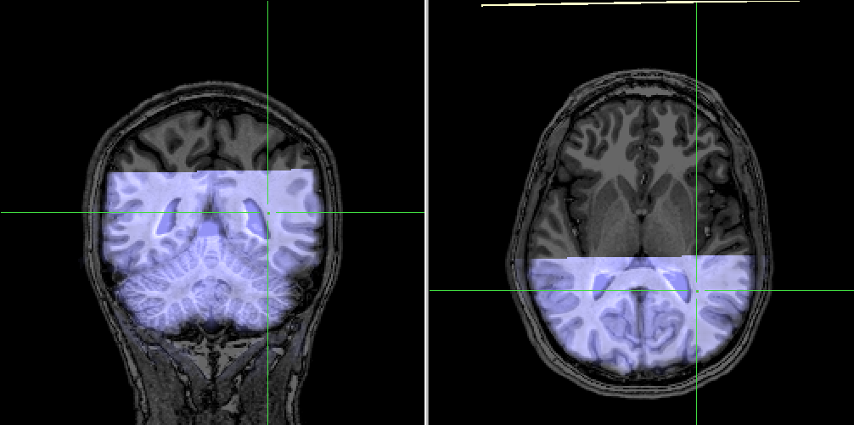

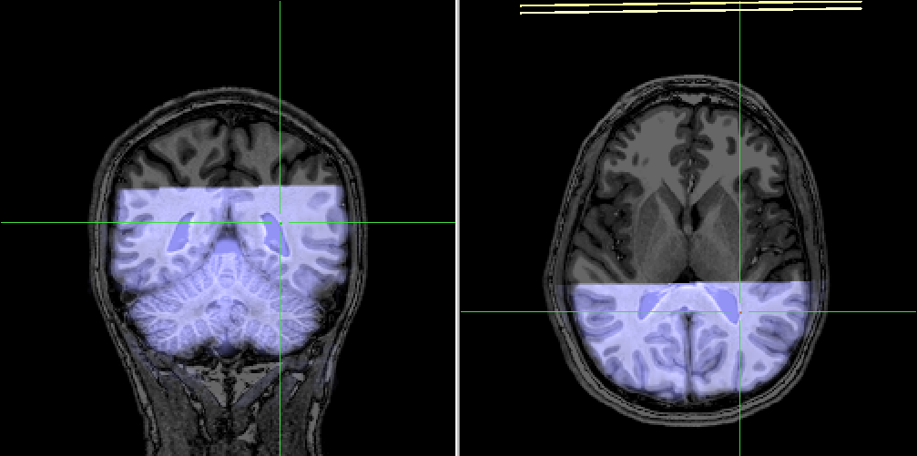

(top) Using only IA. (bottom) Using IA, then manual FA.

* 1. *3D-3D Alignment* (**for experimental data**)
     1. Open your session’s VMR that you made in IB
     2. Deskull it by going to Volumes>Segregate Head from Brain Tissue
        1. If this doesn’t work, you will have to do it manually… see the Deskulling/Inhomogeneity Correction section later in this guide.
     3. Go to 3D Volume Tools>Coregistration then under “VMR-VMR Coregistration” click “Select VMR” and select the ACPC deskulled brain from that subject’s retino_to_go folder.
     4. Click “Align”
     5. To check the alignment, toggle between “Show Transformed” and “Show Target”
     6. From here, you can return to the second part of the autoRA procedure for VirtualBox to make your VTCs.

1. **Retinotopy Preprocessing - BrainVoyager**
   1. *Manual Deskulling*
      1. The goal here is to manually select ONLY the brain, no skull or neck tissue, etc. First open your SAG.vmr file.
      2. If you have already tried Volumes>Segregate Head from Brain Tissue to no avail, do the following.
      3. Volumes>3D Volume Tools then under the Segmentation tab
         1. You first want to click somewhere within the white matter of the brain. If you look at the Global Tools menu on the left side of the screen, click the Info tab, and you will be able to see the intensity of any given voxel. Select a voxel and based on its intensity define minimum and maximum values under the Segmentation tab so that the intensity value of that voxel lies within the min/max range (I usually choose a range of about 30 values to start, so between 150-180).
         2. Click Grow Region.
         3. Click Expand a bunch until you can’t see any more additional voxels being selected.
         4. Now increase your range so your min is your previous max, with the total range being about 20 units (180-200).
         5. Repeat this step until you reach a max of 225, then start doing the same thing in the opposite direction, starting at the first minimum value and working your way down (so the next step would be to select from 130-150, expand).
         6. Keep doing this till you’ve selected the brain ONLY! (This means all of the white and grey matter.) Try to avoid getting any other tissues, but if there is some it is okay.
         7. If you mess up, hit “Reload All” and start over from the beginning (sucks, I know).
         8. If you are happy with your selection, press Reload Marked to show only your deskulled brain, then save as “<id>_SAG_deskulled.vmr”… **DO NOT save while segmenting, because this will save the blue pixels onto your image.**

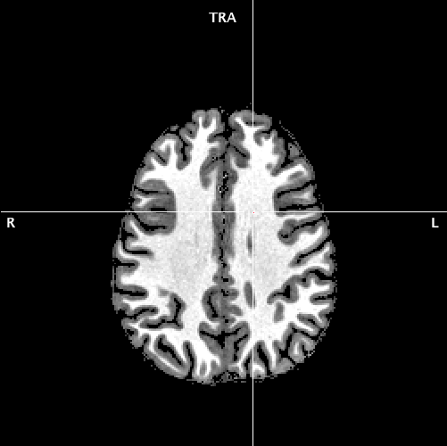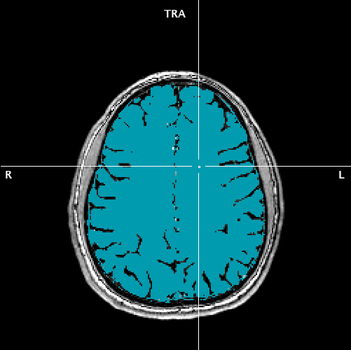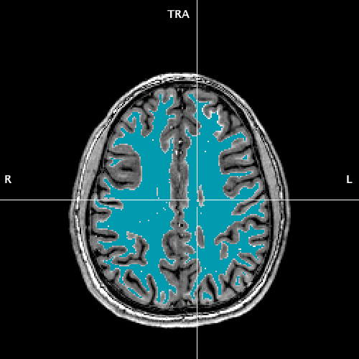

* 1. *Inhomogeneity Correction of White Matter*
     1. Open the _SAG.vmr and go to Volumes>V16 Tools…
     2. Click “Open V16” and select the .v16 file corresponding to the _SAG.vmr
     3. Using the same procedure we used during Manual Deskulling, select ONLY THE WHITE MATTER of the brain (it should look something like the left image on the previous page).
     4. Once you are happy with your selection, go to Volumes>V16 Tools then click the “Presegmentation Based” button, using default options, continue.
     5. This should have balanced the whites of your white matter to be more uniform, allowing them to be easily segmented later on. Now save your file with the suffix “_inhomo.vmr.”
  2. *ACPC Alignment – Anterior/Posterior Commisures*
     1. Open the “_inhomo.vmr” that you just made.
     2. 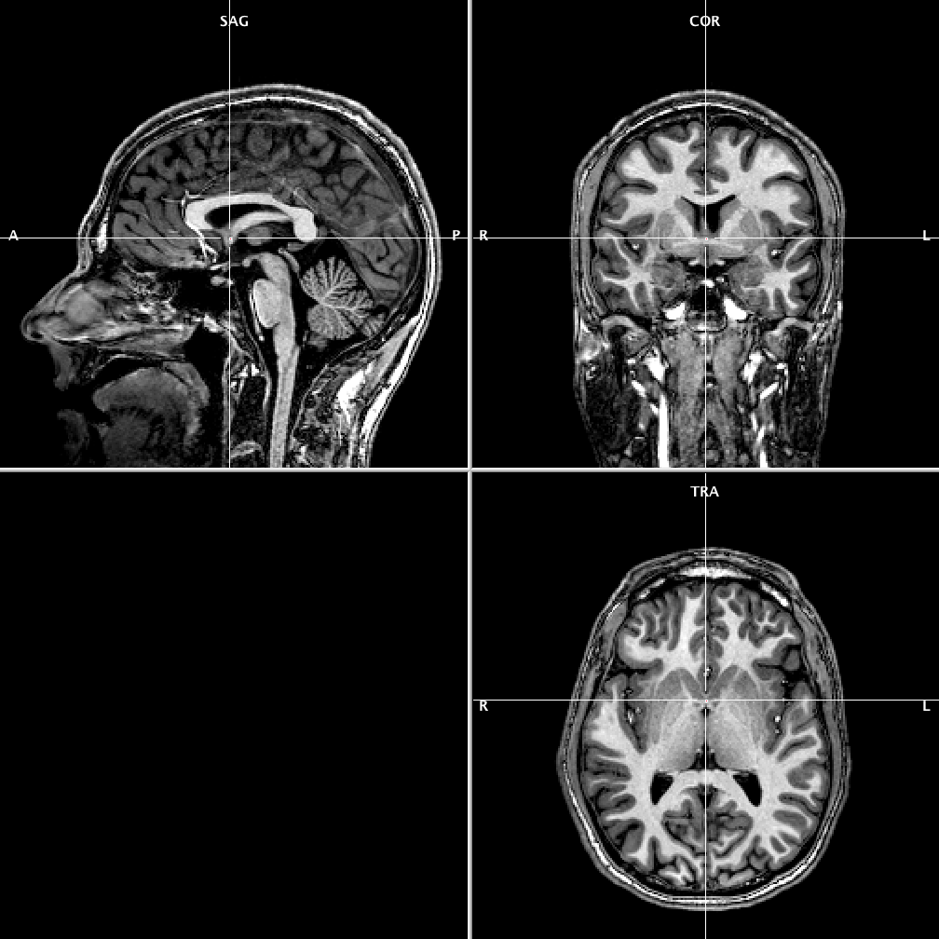Go to Volumes>3D Volume Tools, then the Talairach tab
     3. Click “Find AC Point”
     4. Adjust the transverse view to get the crosshairs on the AC point. Place your crosshairs as superior (top of brain) as possible… it looks like a small white bridge. Press OK when you see something like the image below.
     5. Now click “Find ACPC Plane”
     6. Adjust the X rotation value until you see the PC point in the transverse view lined up with the AC point (do not click on the brain during this step as it will move the crosshairs from the AC point, which will then change around what point you are rotating the brain).
     7. The ACPC plane should travel through the most inferior (lowest) point of the PC (see image below), which looks like a thin white bridge. Click “OK.”
     8. Click “Transform”… this will save out an ACPC.vmr and an ACPC.trf

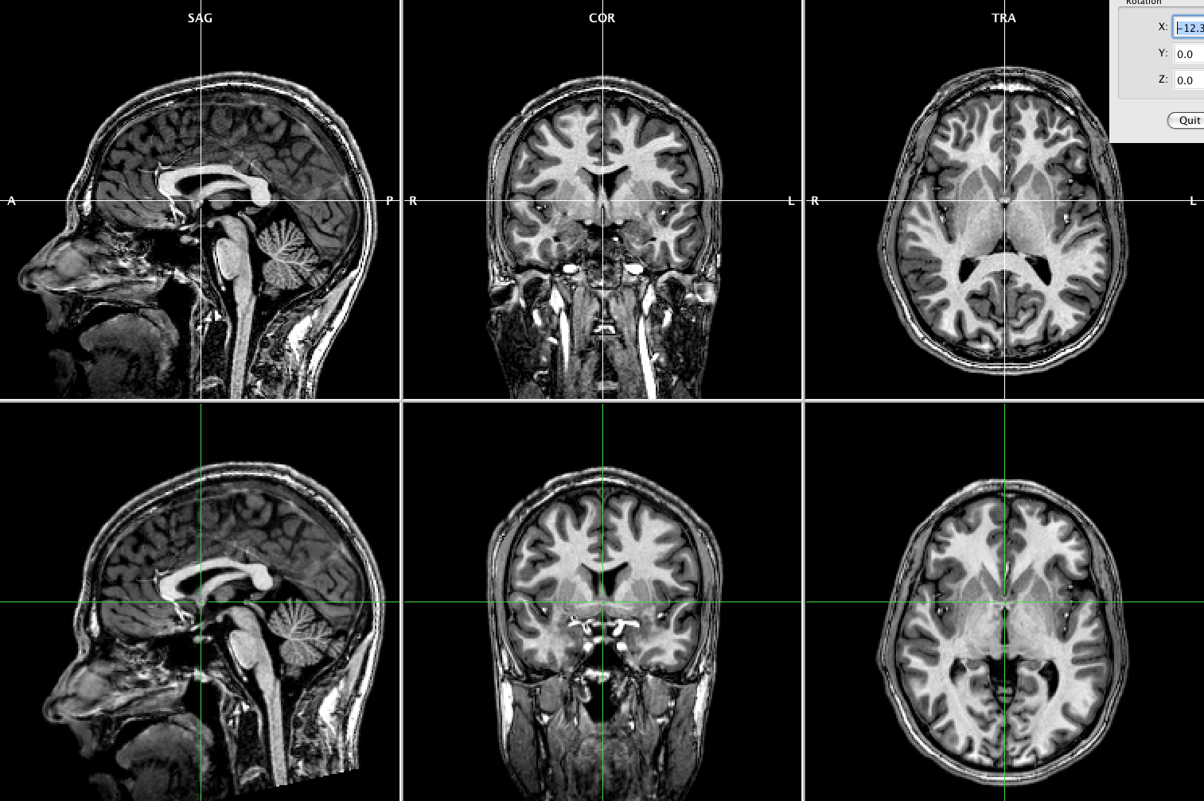

* 1. *Talairaching*
     1. Talairach space is a common referencing space that allows for brains of different subjects to be transformed so that they can all be compared.
     2. First open your “_ACPC.vmr”
     3. Go back to the Talairach tab.
     4. Under the drop down tab, go to each point (AC, PC, etc.), center that point in the crosshair and click “Set Point”. The idea here is to define the dimensional boundaries of the brain… it is better to select too much than too little (i.e. getting some skull is better than cutting off some brain matter).
        1. AC = anterior commissure
        2. PC = posterior commissure
        3. PP = posterior point
        4. SP = superior
        5. IP = inferior
        6. RP = right point (patient’s right)
        7. LP = left point (patient’s left)
     5. “Show” AC to recenter the crosshair and then click “Save TAL”, naming the file with the tag “_TAL”
     6. Click ACPS->TAL to make a talairached VMR. You can double check your position by clicking “Display Partial Grid” and making sure that the brain is correctly bounded by the Talairach grid.
     7. At this point, we are going to make the switch to FreeSurfer for their automated segmentation process, get ready!

1. **Retinotopy Preprocessing – FreeSurfer Segmentation**
   1. *File Conversion: .vmr to .nii*
      1. Now that our anatomical image is preprocessed, we need to segment the white from the grey matter in FreeSurfer. Before we do this we need to get the BV files ready for FreeSurfer.
      2. I’ve written a small bash script that walks you through this process, entitled “FSLtoBVseg.txt”
      3. The first part of the script defines the output directory of your segmentation file, your subject ID, and the anatomical image you plan on using. You will need to edit these accordingly (keep in mind that this segmentation is different than the one used in the FSL processing stream, as we edited it in BrainVoyager first… be sure not to overwrite someone elses segmentations!). Usually you only need to change what is highlighted below.

SUBJECTS_DIR=/Volumes/Data/fMRI_Data/Freesurfer_Subjects

SUB=120626M009

ANATOMICAL=120626M009_R03_SAG_inhomo_TAL.nii

* + 1. Before you continue, you will need to convert your anatomical VMR (<subj ID>_R03_SAG_inhomo_TAL.vmr) into NifTy format using NeuroElf. If you’ve installed NeuroElf correctly, all you need to do to call its GUI is to open Matlab and type neuroelf_gui.
    2. This will open a GUI, and from there you want to go to File>Open and find your inhomogeneity corrected, Talairached vmr (<subj ID>_R03_SAG_inhomo_TAL.vmr).
    3. Next, go to VMR>Export Nifty and enter the filename you defined earlier as ANATOMICAL (see above for an example).
    4. I save these in the retinotopy directory for that subject (for me it is /Volumes/Data/fMRI_Data/Retinotopy/BV_Retinotopy). To be safe, just save it wherever you have been saving all of your BrainVoyager files.
  1. *Segmentation*
     1. **Note:** This step takes a LONG time. Before you start it, make sure you will not be turning off that computer for at least a day. It is possible to work while something is segmenting, but it does tend to slow things down, so it is generally better to set it to run overnight.
     2. First you want to cd into the directory where your new .nii anatomical is saved. Then you will run the segmentation (see below):

cd /Volumes/Data/fMRI_Data/Retinotopy/BV_Retinotopy/$SUB

recon-all -subjid $SUB -i $ANATOMICAL –all

* 1. *Mask Creation*
     1. Once your recon is done you will be able to find all of the segmentation files in the subject directory you defined when you installed FreeSurfer.
     2. To create files that are useable in BrainVoyager we need to create a volume mask for the white matter (a volume which labels only white matter). This can be done by typing the following:

mris_volmask --save_distance $SUB

* + 1. This command makes a volume mask that demarcates the white/grey matter boundary as 0, with white matter having a value of 0>x>=+3 and non-white matter having a value of -3>=x>0. (It will look like white matter is white with a fuzzy border, everything else will be black).
    2. These masks are made for each individual hemisphere and are named lh.dwhite.ribbon.mgz/rh.dwhite.ribbon.mgz and are saved in your segmentation folder in the mri directory.
  1. *File Conversion: .mgz to .nii to .vmr*
     1. We now need to import these into BrainVoyager, first converting them into .nii

cd $SUBJECTS_DIR/$SUB/mri

mri_convert lh.dwhite.ribbon.mgz lh.dwhite.ribbon.nii

mri_convert rh.dwhite.ribbon.mgz rh.dwhite.ribbon.nii

* + 1. Next, go back to NeuroElf and convert them into .vmrs
       1. File>Import Analyze to VMR
       2. Choose lh.dhwite.ribbon.nii under mri in segmentation directory.
       3. Output as “<subj ID>_LH_FSLseg.vmr” into your BrainVoyager retinotopy folder.
       4. Repeat for right hemisphere, changing the names accordingly.

1. **Retinotopy (each step from this point must be repeated for the other hemisphere)**
   1. *VTC Creation*
      1. Because VTC creation is buggy and crashes frequently, now is a good time to do it, as the next few steps are relatively systematic, but take some time, so you can multitask by running the VTC creation in parallel with mesh creation etc.
      2. Refer to step 2a of AutoRA section previously to make your VTCs.
   2. *Preparing Segmentation*
      1. Ok, FINALLY you’re ready to start doing the real retinotopy work. You want to open your newly made segmentation vmr (for this example I will be starting with 120831M076_LH_FSLseg.vmr).
      2. You should see all of the white matter in one hemisphere as white with a fuzzy border. Because of how FreeSurfer created this volume, we need to select white matter up to the white/grey matter boundary (which lies exactly halfway between white and black… at 50% grey).
      3. To do this, go to Volumes>3D Volume Tools then the Segmentation tab.
      4. Under min, put 115 (which is about halfway between BVs values for black and white… 0 and 225, respectively) then put 225 under max (BV’s value for white), then click “Grow Region.”
      5. 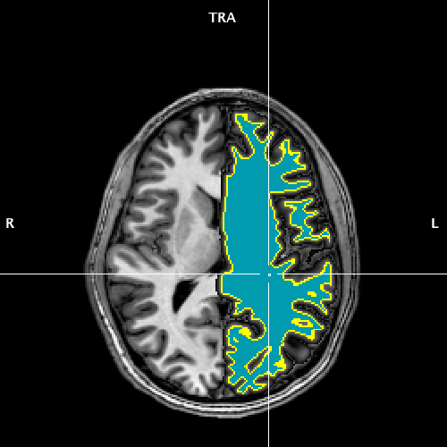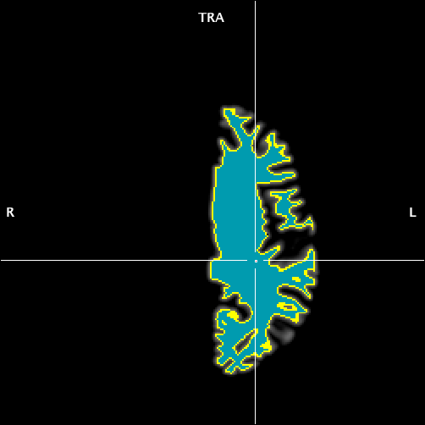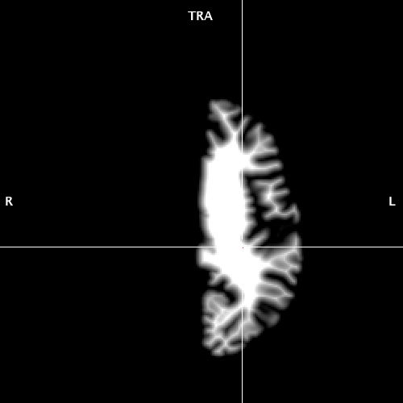This should give you a blue selection where all of your white matter is. In the 3D Volume Tools dialogue under “Reconstruction” click “Prepare” to define the boundary of the segmentation. At this point I double check to see if the segmentation is ok, by going to File>Load Secondary VMR and selecting my “_inhomo_TAL.vmr.” Toggle between your segmentation and the original anatomical by pressing F8 and F9, just to make sure that the segmentation is accurate and lined up. Save your segmentation file as your root filename plus “_segmented.vmr” (e.g. 120831M076_R03_SAG_inhomo_TAL_LH_segmented.vmr)
   3. *Mesh Creation*
      1. Take your segmentation file and be sure that the overlaid anatomical image is not visible.
      2. Go to Meshes>Create Mesh then press “Reconstruct.”
      3. Smooth the mesh by going to Meshes>Mesh Morphing, then check “Smoothing” at 150 iterations, hit GO.
      4. Save your mesh as your root filename with “_folded” at the end (e.g. 120831M076_R03_SAG_inhomo_TAL_LH_folded.srf)
      5. Then simplify the mesh by going to Meshes>Mesh Simplification. Make sure the number of vertices is 80,000 and then hit GO (this will add the tag “_D80k”).
      6. Next, go to Meshes>Mesh Morphing and then check “Smoothing Mode” at 500 iterations and press GO.
      7. Check the mesh for any issues (holes, bumps, etc.).
         1. These are rare, but if you notice any of these you will want hold command and click where the imperfection is. This will bring the crosshairs onto the segmentation image.
         2. Under the Segmentation tab, you can manually edit the segmentation by checking “Enable” under “Drawing with Mouse”
         3. Holding Shift and clicking on the segmentation will allow you to erase voxels, while holding Command will allow you to draw them.
         4. Erase/Draw so the imperfection is gone, then save your segmentation file.
         5. Return to step C2
      8. If there are no problems, inflate again at 500 iterations.
      9. 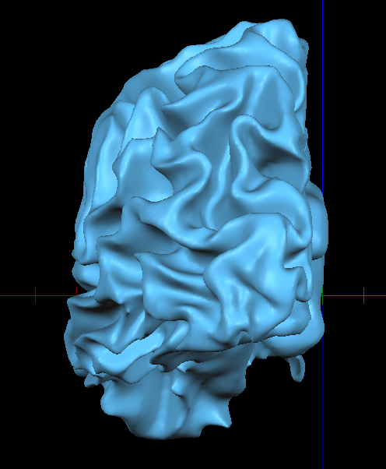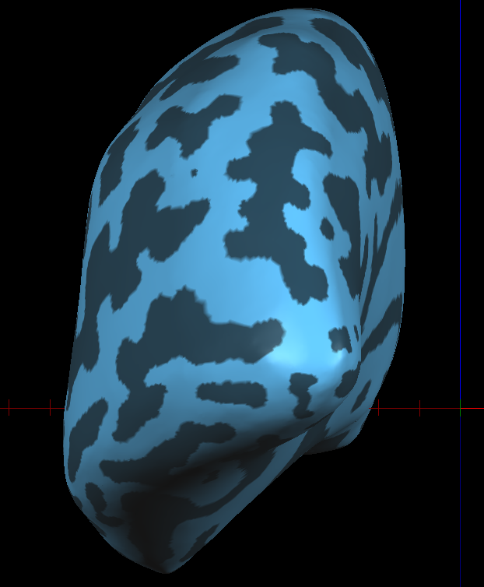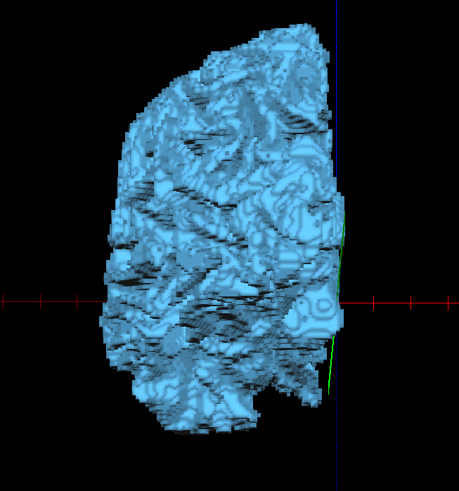To overlay gyri and sulci, go to Meshes>Mesh Surface Functions and click “Curvature,” then click “Smooth” 8 to 10 times.
      10. Now save your mesh as the root file name, plus “_inflated” (e.g. 120831M076_R03_SAG_inhomo_TAL_LH_inflated_D80k.srf)
   4. *Surface Mapping*
      1. Hopefully all of your VTCs have been created at this point. If not, make them and come back.
      2. Create averaged .VTCs for each condition (eccen/polar) by going to Volumes>Combine 3D Data Sets, check “VTC’s” and then click “Add Files.” Select all the files of one condition in your 6_VTC folder and then save them as “<subj ID>_<polar(or)eccen>_average.TVC”
      3. Open your inflated mesh (“_inflated_D80k.vmr”)
      4. Polar Mapping
         1. First go back to volume space (go to the tab where your VMR is).
         2. Link your VTC by going to Analysis>Link 3D Time Course (VTC) Files and then selecting the polar average file you just made.
         3. Now go to Analysis>Compute Linear Correlation Maps.
            1. Click “Load RTC”
            2. Depending on what hemisphere you are in, load the appropriate offset RTC file from Retinotopy>_RTCs>32secpercycle_RTCs

Left hemisphere – polar: offset = 15

Right hemisphere – polar: offset = 5

Your offset will not necessarily end up as one of these numbers, these are good places to start.

* + - * 1. Under “Cross correlation” check “Enable” and enter 8 lags.
        2. Click GO.
      1. Now go back to your mesh tab and go to Meshes>Surface Maps (or press cmd R)
         1. Click “Create SMP”
         2. Under “CC overlay type” check “Lag values”
         3. Check “Use LUT” and select red_yellow_green.olt
         4. Go to options and name your map “<LH(or)RH>_Polar_Off<offset value from RTC>”
         5. Press OK then OK again and examine your mesh. What you want to see are clear striations going towards the apex of the occipital pole.
         6. If the striations aren’t clear, save your SMP by pressing cmd R and pressing “Save SMP” – name your map “<subject ID>_<hemisphere>_map”. Then go back to step 4a and make another surface map but shifting the Offset one point in one direction or the other. Repeat until you get the clearest striations possible.
         7. This part of the process is more of an art than a science, so ask for help if you’re new to it, it takes a few times before you really get an eye for retinotopic regions (see the next page for examples… top = offset of 16, bottom = offset of 14).
         8. To remember which offset in the .smp is optimal, I add an asterix at the end of the name. Once you get a nicely balanced surface map, save your .smp.

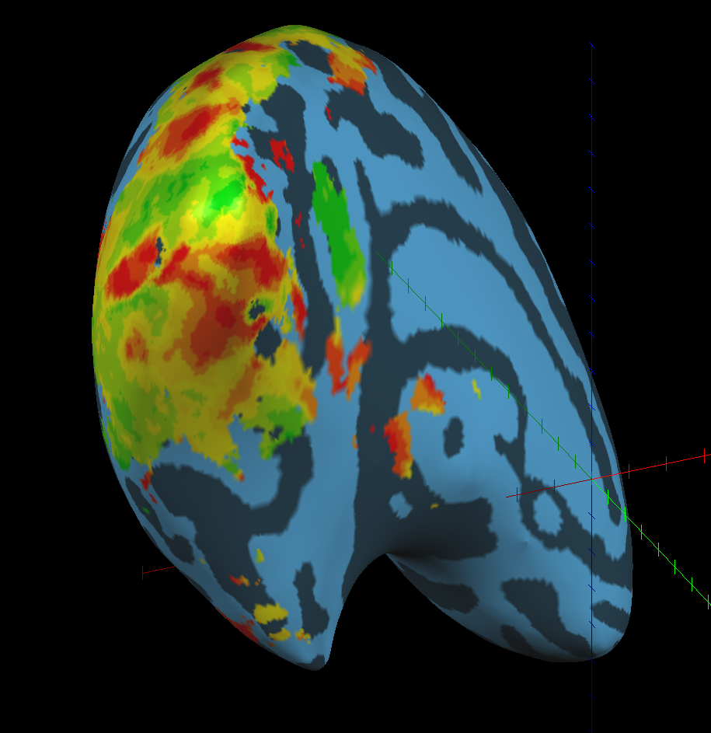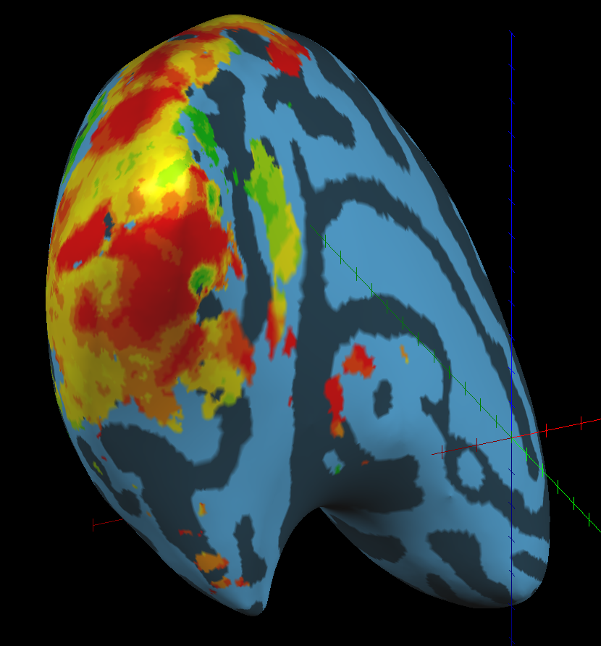

Note the lack of detail

in this image

* + 1. Eccen Mapping
       1. First go back to volume space (go to the tab where your VMR is).
       2. Link your VTC by going to Analysis>Link 3D Time Course (VTC) Files and then selecting the eccen average file you just made.
       3. Now go to Analysis>Compute Linear Correlation Maps.
          1. Click “Load RTC”
          2. Depending on what hemisphere you are in, load the appropriate offset RTC file from Retinotopy>_RTCs>32secpercycle_RTCs

Left hemisphere –eccen: offset = 5

Right hemisphere – eccen: offset = 5

Your offset will not necessarily end up as one of these numbers, these are good places to start.

* + - * 1. Under “Cross correlation” check “Enable” and enter 8 lags.
        2. Click GO.
      1. Now go back to your mesh tab and go to Meshes>Surface Maps (or press cmd R)
         1. Click “Create SMP”
         2. Under “CC overlay type” check “Lag values”
         3. Check “Use LUT” and select EccenRedGradient.olt
         4. Go to options and name your map “<LH(or)RH>_Eccen_Off<offset value from RTC>”
         5. 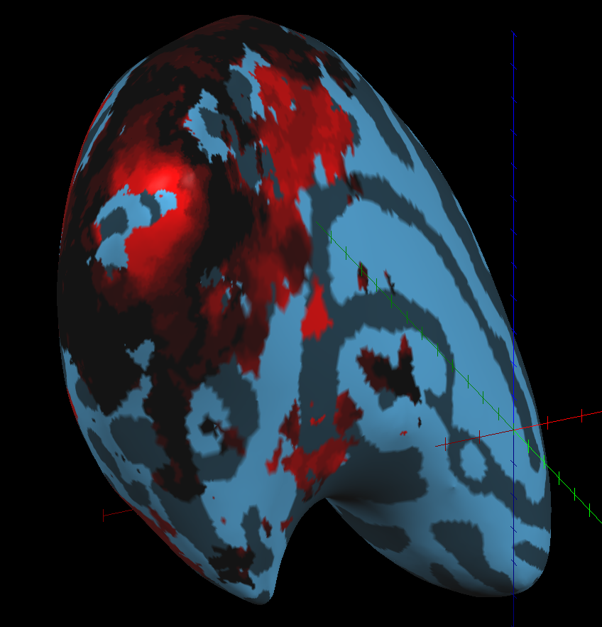Press OK then OK again and examine your mesh. You should be seeing red around the occipital pole, that may outline V1 and V2. I typically don’t use eccen maps for retinotopy too much, but others do, and it is important for some studies.
         6. Once you’re satisfied with your map, save the smp.
    1. *Cutting and Flattening*
       1. 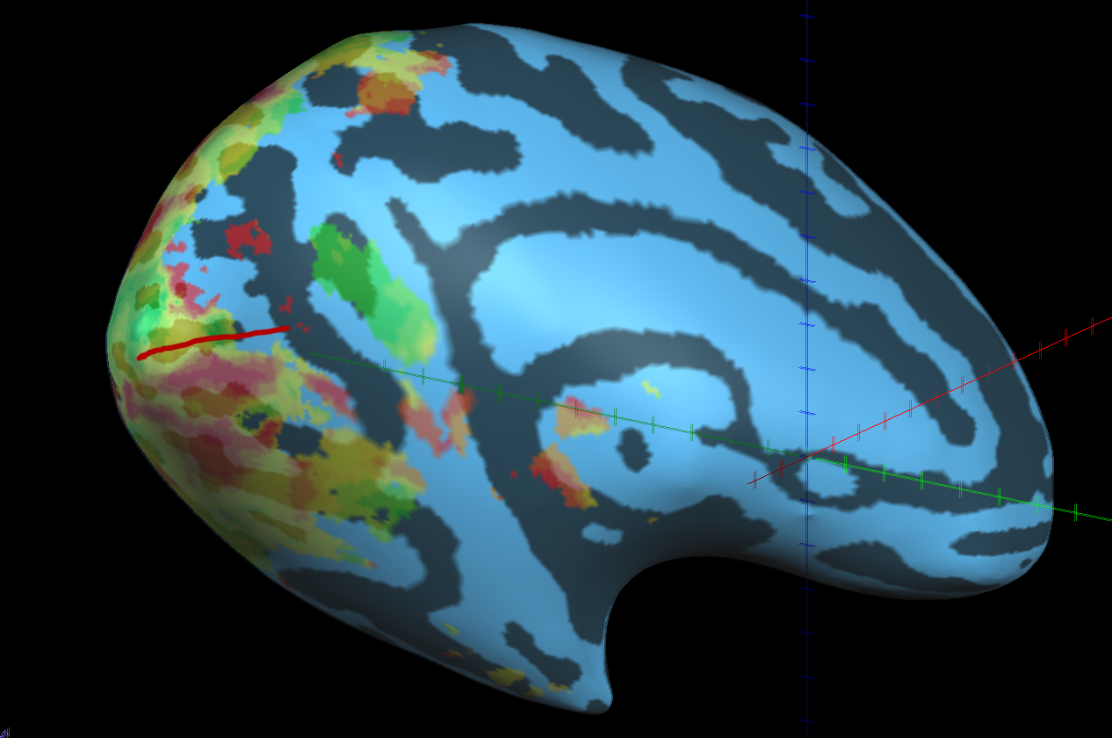Once you have a nicely balanced .smp you will need to flatten your inflated brain. You first need to determine where to make your cut. You want to cut along the calcarine sulcus from near the occipital pole along the sagittal towards the front of the brain. You can see the anatomical calcarine by toggling your .smp overlay, but you also want to pay attention to the .smp itself, as you want to be cutting evenly down the patch of yellow activation along the calcarine (see image below).

* + - 1. To make your cut press the “Select Vertex Mode” button on the tool palette on the right side of the window – it looks like a white face with a pointer on it.
      2. 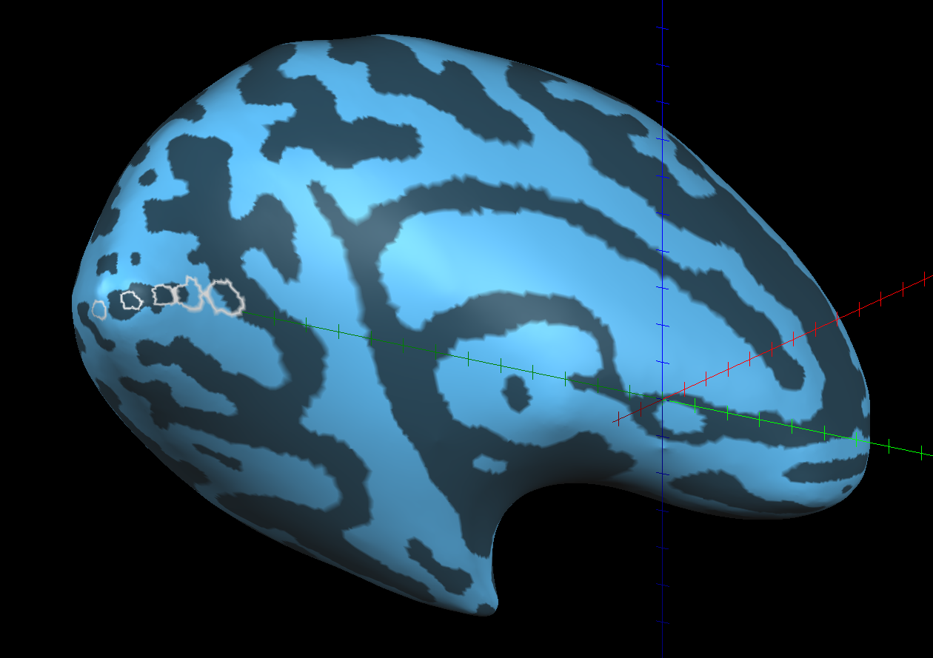Then hold shift and make 5 points along the line you wish to cut (you should see several circles of mesh form, if not, make sure your VTC is linked).
      3. To make the cut go to Meshes>Mesh Morphing and then click the “Auto Cut” button near the bottom.
         1. Check off “Use specified calcarine cut”
         2. Press Apply, then GO.
      4. 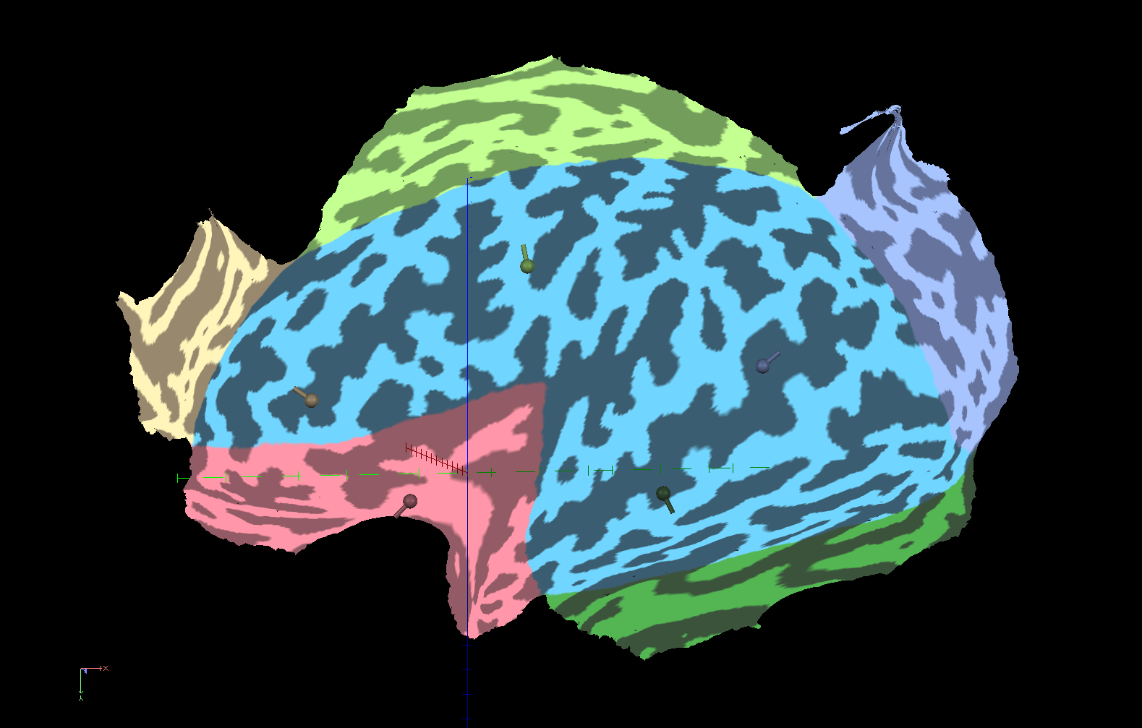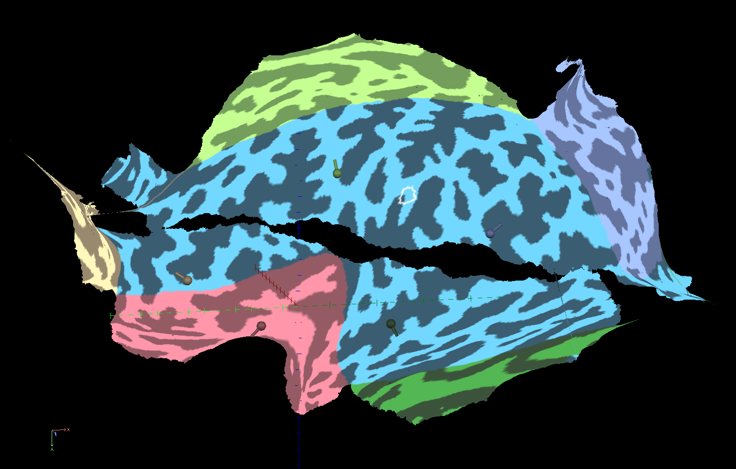It should look like the image immediately below, but it can sometimes go terribly, terribly wrong (see bottom image)… if this happens, all you can really do is reload the original inflated mesh and try again.
      5. If you have a good flat map, go to Meshes>Mesh Morphing, check “Distortion Correction” at 2000 iterations, then press GO.
      6. This step can go awry too, if that happens, you will probably need to go back and make a slightly different cut… there’s not much you can do to intelligently fix the problem. Assuming everything went ok, you should see something like the image below.

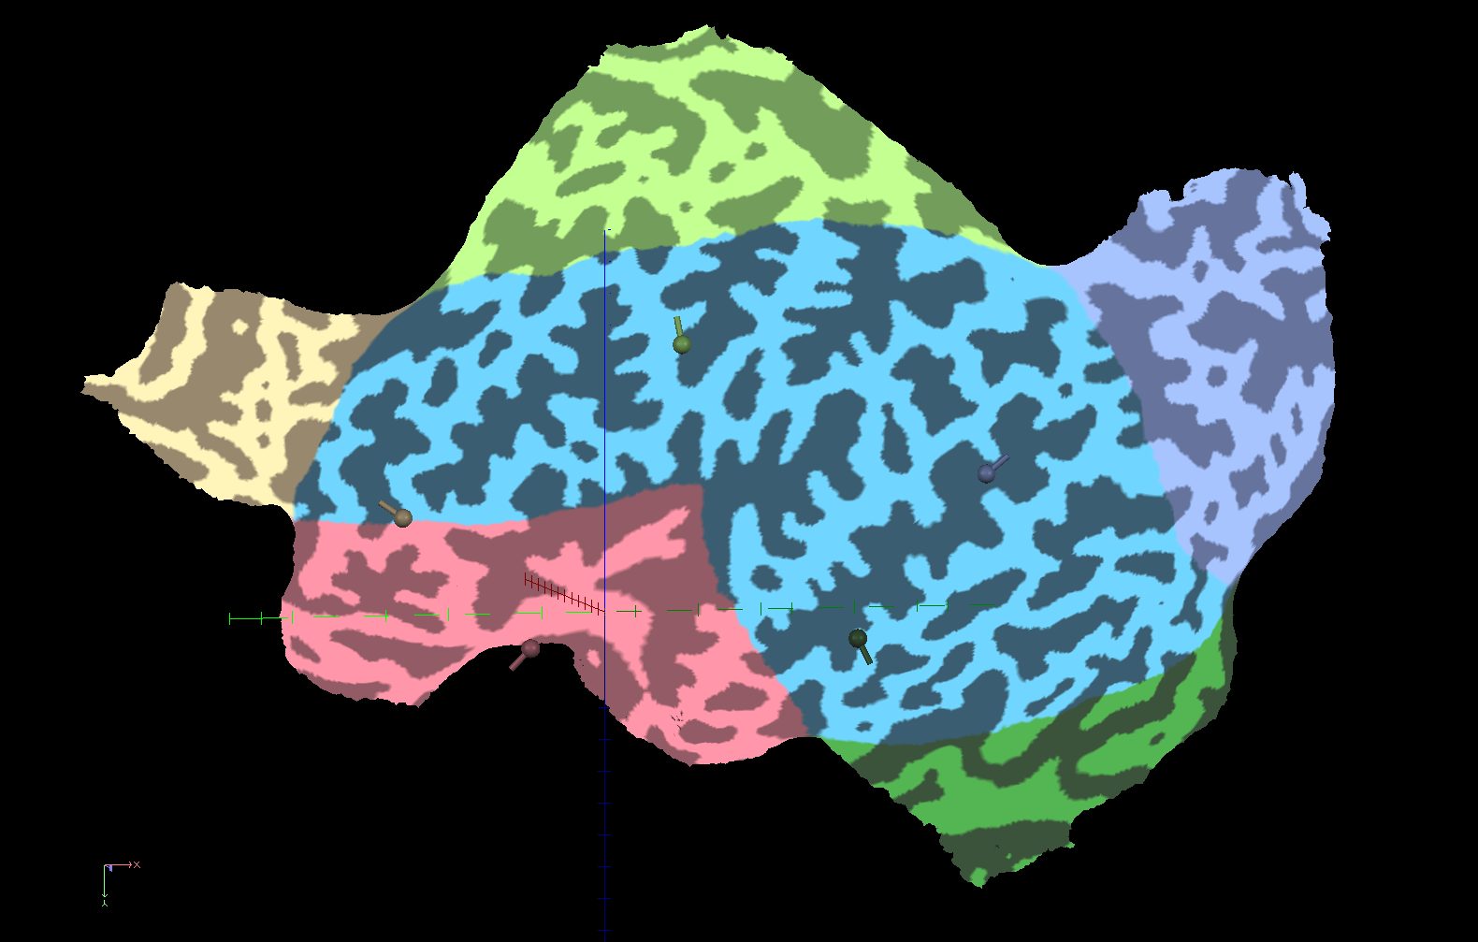

* + - 1. We want to get rid of the funky colors by going to Meshes>Mesh Surface Functions, pressing “Reset colors” then “Curvature”. You should see the gyri and sulci again – click “Smooth” 8-10 times.
      2. To get rid of the different colored pins randomly stuck into your mesh, simply save the mesh as the root name plus “_flat” (e.g. 120831M076_R03_SAG_inhomo_TAL_LH_flat_D80k.srf)
      3. Next you want to plot your surface maps onto the new flat map. Do this by simply going to Surface Maps (cmd R) and loading your maps file that you made earlier.
         1. First overlay the eccentricity map, then save your mesh as root name plus “_eccen” (e.g. 120831M076_R03_SAG_inhomo_TAL_LH_eccen_D80k.srf)
         2. Next, overlay your polar map, choosing the asterix-marked overlay that you made earlier. Save this mesh as root name plus “_polar” (e.g. 120831M076_R03_SAG_inhomo_TAL_LH_polar_D80k.srf). If you’re ready to continue, leave this mesh open.

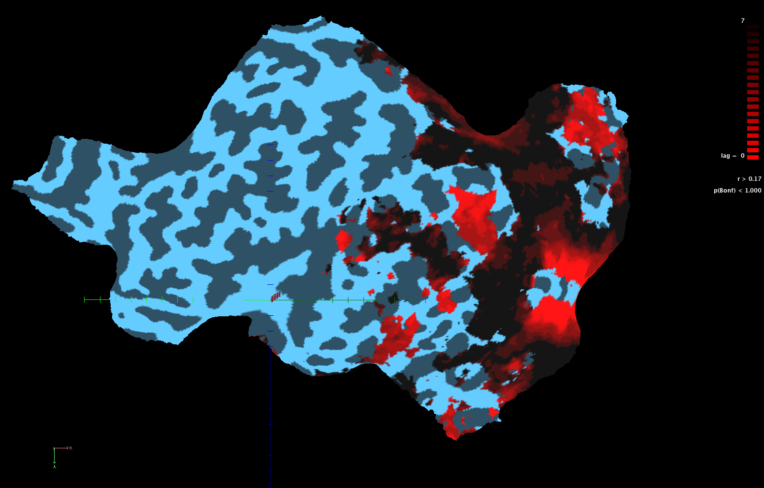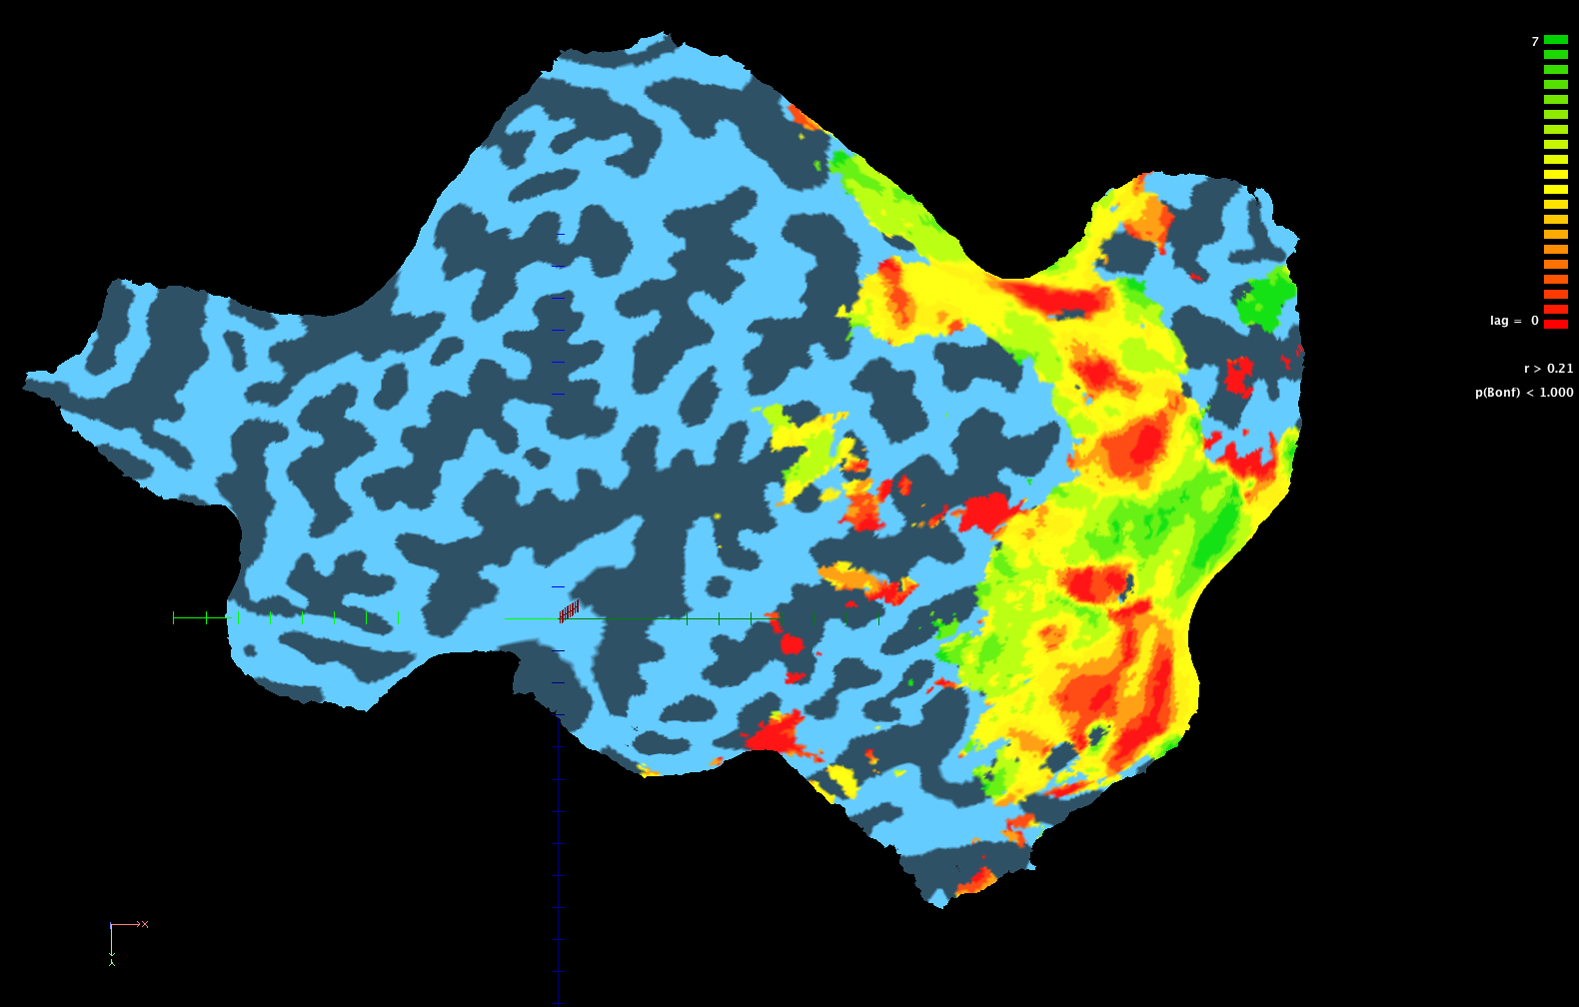

* + 1. *Prospective Delineations*
       1. Before doing the delineations in BrainVoyager, you’ll want to draw them by hand in Photoshop, just to give you something to reference when doing them for real.
       2. Take a screen shot of your polar map by pressing Command+Shift+4 and selecting a bounding box of the capture you want. This will save a picture to your desktop
       3. Open this image in Photoshop and make a new layer. Using the pen tool or brush tool, delineate each area by hand – it doesn’t have to be pretty, as long as it’s accurate, it is only to reference later. This is something that you need to develop an eye for, watch someone do it first, and when you do it by yourself, be sure you have a previous retinotopy to reference. Your first few retinotopies you may want to get another lab member to check these before you continue.
          1. What you are looking for here are cycle shifts in the colors of the surface map (in our case they are representative of activation over time). A full cycle of the color map we use will go all the way from red to green, a half cycle is from either yellow to green or yellow to red.
          2. V1 through V3 are typically half cycle shifts, alternating between green and yellow dorsally, and red and yellow ventrally. These areas are usually easy to delineate.
          3. V3A (dorsally) and V4v are full cycle shifts, meaning they will typically display a full color shift from red to green. These areas are a little harder to find.
          4. As I said, this process is hard to explain in words, the best way to learn is by watching someone with experience and then doing.
          5. Refer to the image below for an example delineation and labeled areas.
       4. 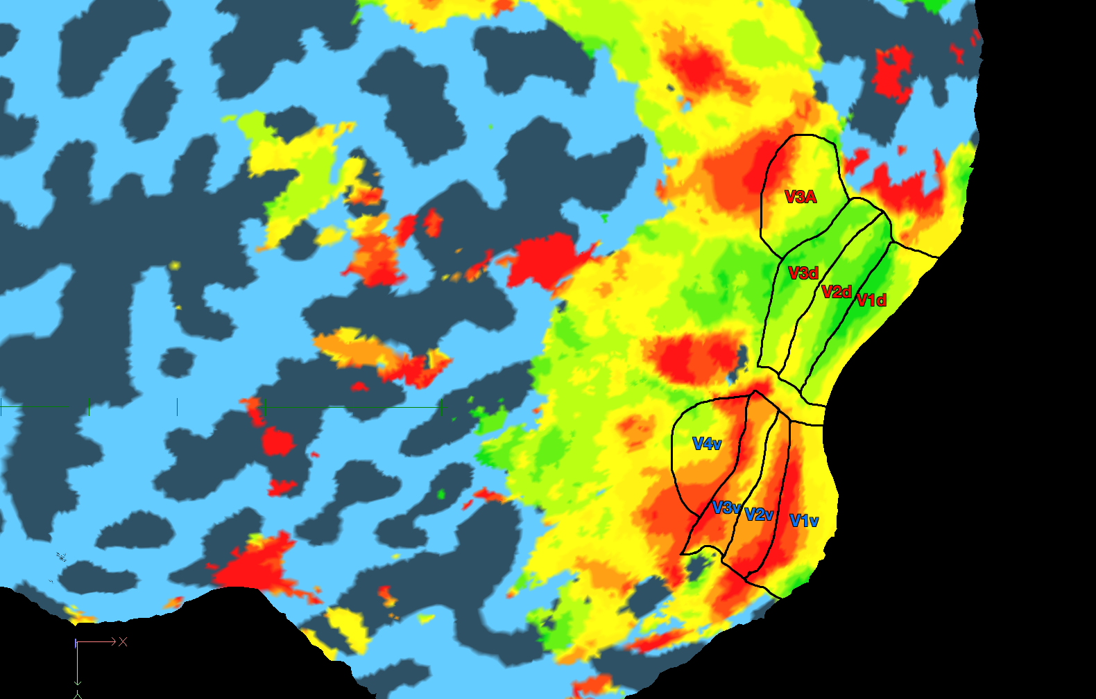Once you’ve made the delineations in a new layer, save the file as “<subject ID>_<hemisphere>_prospective_delineations.psd”
    2. *BrainVoyager Delineations*
       1. Close out of all BrainVoyager tabs if you have any open and then reopen your anatomical (_TAL.vmr)
       2. Load in the .srf with the “_polar” tag and the appropriate hemisphere.
       3. Have Photoshop open with your prospective delineation for that hemisphere and place that window next to the BrainVoyager window, so you can reference your sketch from earlier.
       4. First set undo by right clicking the mesh and selecting “Save Colors for Undo”
       5. It’s usually easier to draw by setting the display mode to wire frame, by clicking the button on the right tool palette that looks like a wire cube.
       6. Go to Meshes>Painting and Cutting
          1. Make sure “Fill through all colors except region filling…” is checked
          2. Click “Load .BCL” and load “TongLab_RetinoVOIcolors.bcl” located in the retinotopy directory
          3. This loads a preset color index that we use for our delineations.
          4. Press Ok.

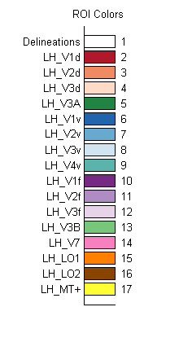

* + - 1. Click the “Draw/Cut Mesh Mode” button (red face on the right hand tool palette) and make sure under “Painting and Cutting” that you are in color index 1 (white).
      2. Draw white delineations by clicking while holding down the shift key, trying to follow the Photoshop sketch as closely as possible. I recommend “Saving for Undo” very often… after every area you draw, as this part is easy to mess up. You should end up with an image similar to your prospective delineations, just with white lines.
         1. If you wish to stop and start at another point, unclick the white face, or you will draw lines where you don’t want them.

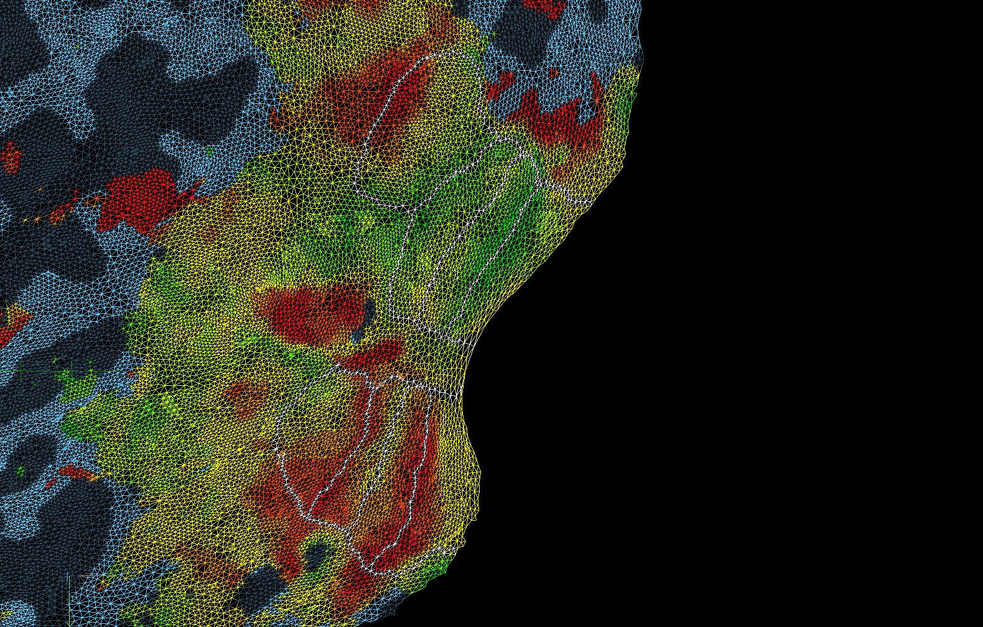

1. Once you have all of your delineations drawn out, its time to start filling them.
2. Go to Meshes>Painting and Cutting and then change your color index to 2 (this will be a deep red that demarcates V1d). Make sure “Fill through all colors…” is still checked.
3. Click “Fill Mode” (the green face on the right palette, and then click within V1d to fill it.

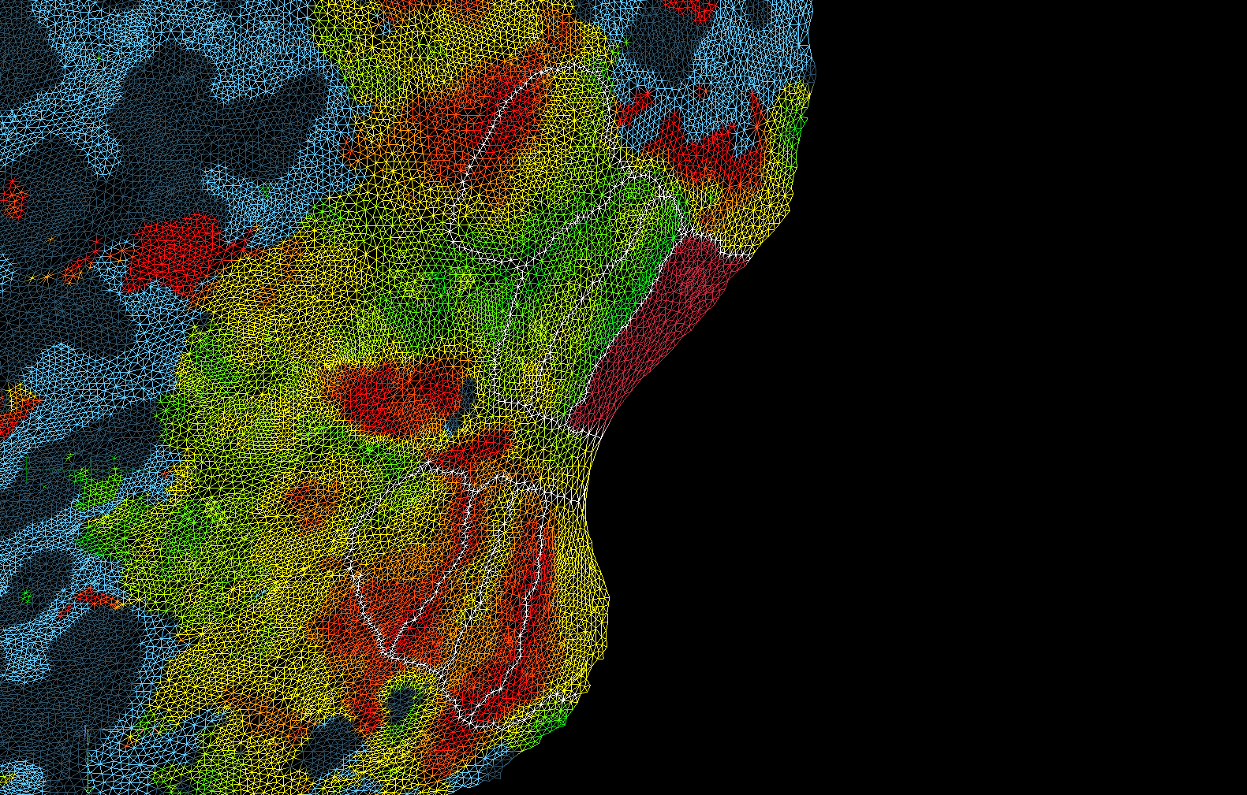

1. Go back to Meshes>Painting and Cutting and then change your color index to 3 (this will be a salmon color that demarcates V2d).
2. Fill V2d.
3. Continue in this fashion until each area is filled with its respective color, but still has its white outlines (make sure to save for undo often!!!)

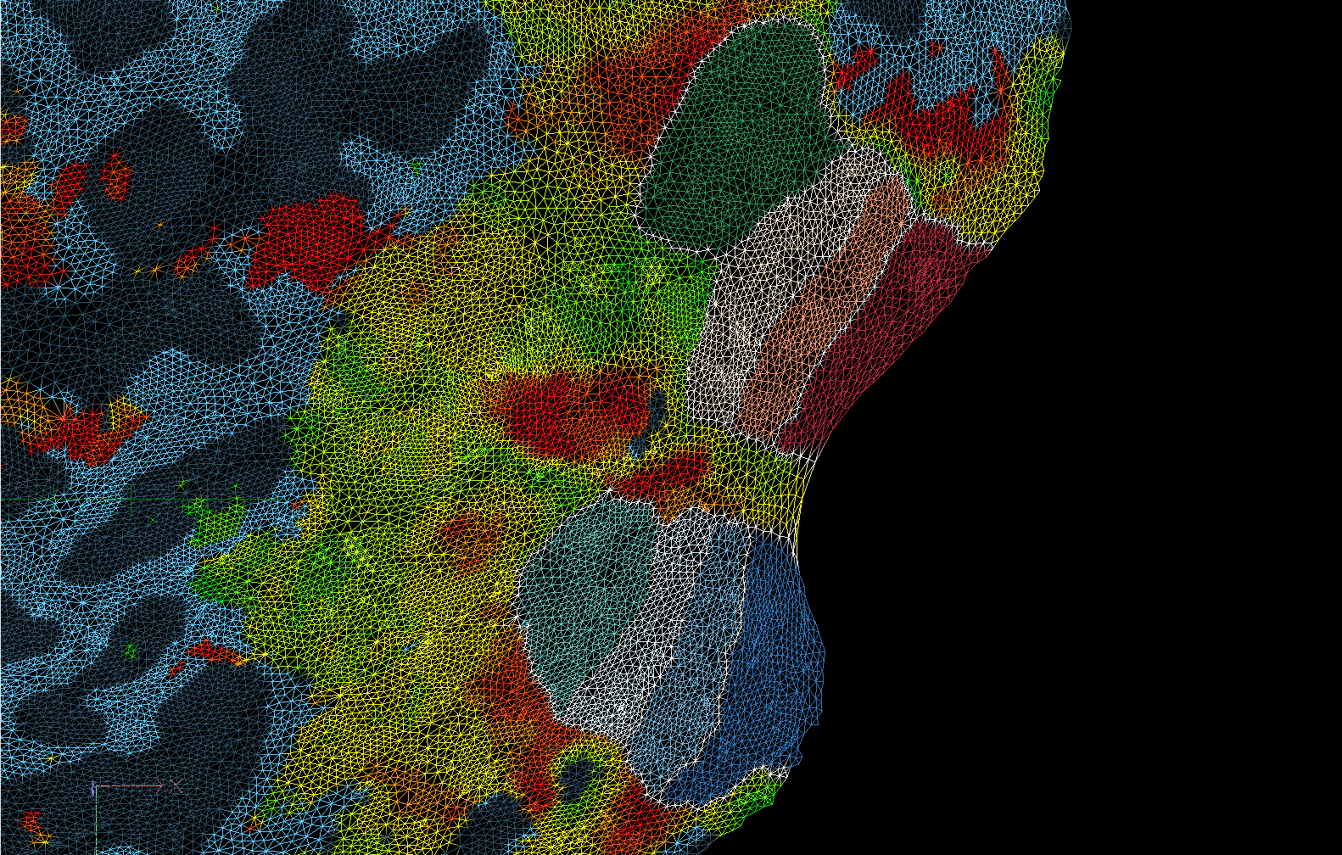

1. Next we want to recolor the white lines so they match the colors of the regions they surround. Go to Meshes>Painting and Cutting and *UNCHECK “Fill through all colors…”* then select the color index you want to work from.
2. Click the Draw Tool (red face) and draw dots of your current color index on each end of the white line you want to fill next to the corresponding cortical area.
3. 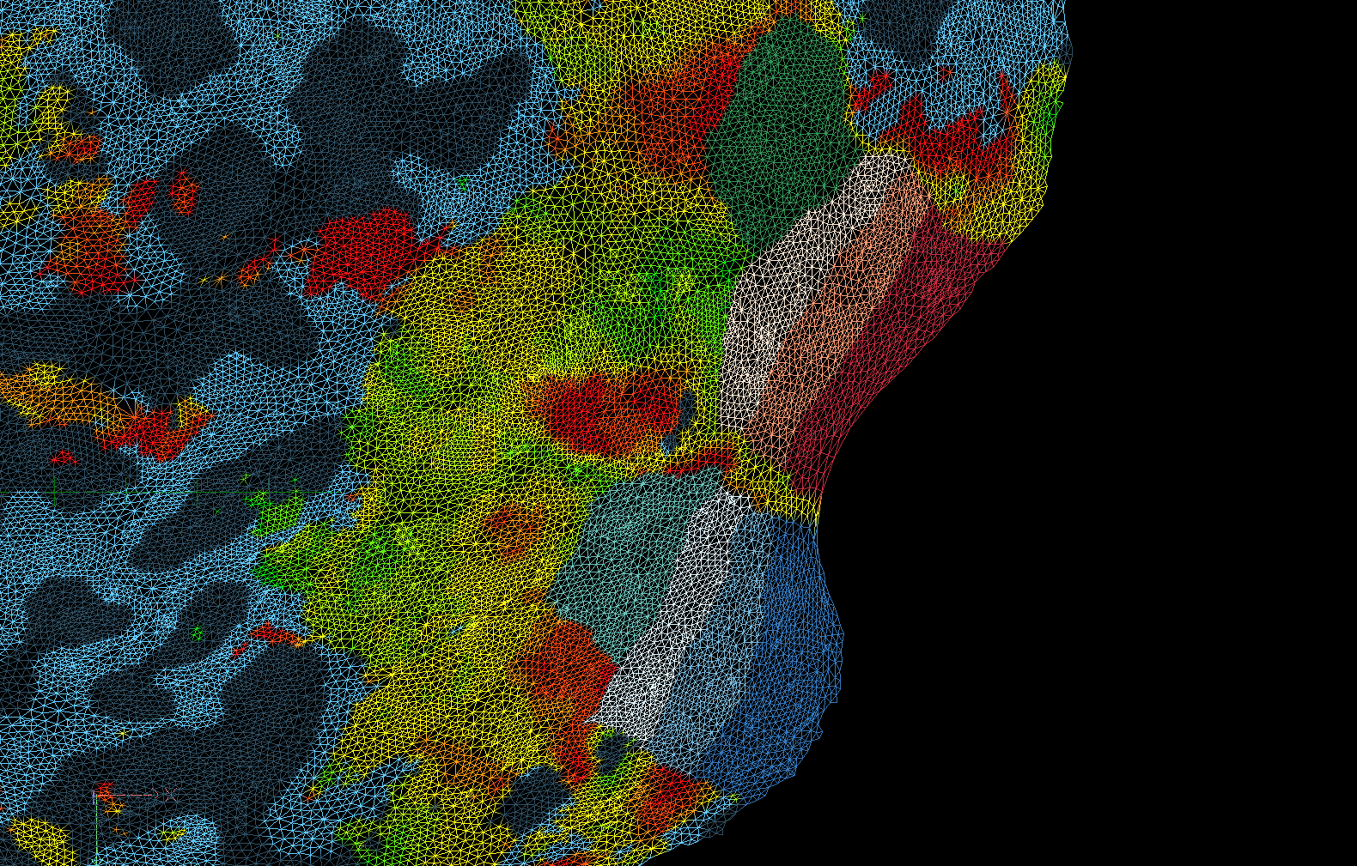Click the Fill Tool (green face) and fill the line segment between those two points (this part can be tricky… be sure to save for undo often). Repeat until all white lines are no longer present.
4. When you are done, save as root name with the tag “_delineated” (e.g. 120831M076_R03_SAG_inhomo_TAL_LH_delineated_D80k.srf)
   * 1. *POIs and VOIs*
        1. To define each patch of interest (POI), right click on the mesh and click “Define Patch of Interest (POI)”
           1. Choose a paint index.
           2. Type the name of the area that corresponds to that index.
           3. Press OK.
           4. Repeat for each POI in that hemisphere.
           5. After adding all the POIs, save a .poi file with the name “<subject ID>_<hemisphere>_POIs.poi”
        2. Go to Meshes>Patch of Interest Analysis, click the Options tab, and then the POI Functions tab.
           1. Make sure “Expand POI along vertex normal” is set from -1mm to 1mm.
           2. Click “Create” to make a corresponding set of VOI labels.
           3. A “Volume of Interest Analysis” dialogue box should have opened.
        3. In the VOI Analysis box select both sides of V1 by holding command and clicking V1d and V1v.
           1. Press “a OR b”
           2. New value = V1_combined
           3. Repeat for V2 and V3
           4. Save your VOI as “<subject ID>_<hemisphere>_VOIs.voi”

**You have now finished the retinotopy! What a trip, eh?**